Antioxidative potential of defatted meal from exotic collections of Brassica juncea (Indian mustard)

Poonam Papola, H. Punetha¹ and Om Prakash

Department of Chemistry, ¹Department of Biochemistry, College of Basic Sciences and Humanities, G.B. Pant University of Agriculture & Technology, Pantnagar, U.S. Nagar, Uttarakhand, 263145, INDIA

Corresponding author email: punetha_hp@rediffmail.com

ABSTRACT

The present study directed to evaluate antioxidant potential of methanolic extract from defatted meal of twenty Exotic collections (EC) of Brassica juncea for selection of desirable breeding germplasm having functional value in term of antioxidative potential. Being antioxidative in nature Brassica juncea may be used as alternative in place of synthetic ones. Total antioxidant activity and phenol content was observed in the range 14.204 to 26.973 mg/g and 5.39 to 7.47 mg/g respectively. In term of IC₅₀ value Hydroxyl radical, nitric oxide & superoxide radical scavenging was maximum in EC564649 where as DPPH radical scavenging was maximum in EC552583 (YS). Metal chelating activity was maximum in EC564641.

Keywords: Exotic collections, Brassica juncea, Antioxidative, phenol content

Introduction

Brassica juncea is an important oil seed crop of family Brassicaceae which comprises of 400 genus and 4,000 species (Dal Prá et al. 2013). High levels of antioxidant metabolites in Brassica vegetables provide beneficial health effects (Ferreres et al. 2007). Dietary antioxidants include vitamins (especially vitamin A, C, E, K and B-6), carotenoids, zeaxanthin, thiols, anthocyanins, dietary glutathionine soluble sugars, folate, selenium, bioactive plant phenols etc. (Bhandari and Kwak, 2015). Natural health products and food obtained from plant have some common biological properties like antioxidant activity, capacity of scavenging electrophiles, ability of scavenging active oxygen species, inhibition of nitrosation, metals chelating ability, the capability of production of hydrogen peroxide in the presence of certain metals, and the potential to alter certain enzyme activities (Terpinc et al. 2012). With preventing our body from harmful free radicals, antioxidants also prevent different pharmaceuticals and food items from getting spoiled. Antioxidants showed their contribution both to the first and second defense lines against oxidative stress and may therefore prevent chronic diseases, such as cardiovascular disease, cancer, and diabetes (Podsędek, 2007). In recent times, awareness has increased to a great extent in finding naturally occurring antioxidants as use in foods and medicinal materials to alter synthetic antioxidants, which are being constrained due to their carcinogenic effects (Riaz, 2012 and Punetha et al. 2015). The fat free meal of Indian mustard is good source of antioxidant which can be utilized for preparation of functional food as well as for selection of breeding material having desirable antioxidative level. Keeping this fact in mind present investigation focused to evaluate the antioxidative potential of Exotic Collections (EC) of Indian mustard.

Mateials and methods
Source of plant material
The seed samples of 20 EC genotypes were collected from the Crop Research Centre, Govind Ballabh Pant University of Agriculture & Technology, Pantnagar after proper validation by Plant breeder.
Preparation of Defatted mustard meal
Crushed seeds of mustard were packed in Muslin cloth. This thimble was placed in Soxhlet apparatus and defatting was done at 60° C using petroleum ether. After 8-9 times of repeated extraction Oil was extracted by evaporating the petroleum ether extract and the defatted meal obtained was used further for antioxidative potential.
Preparation of methanolic extract
0.1 g of defatted meal was mixed thoroughly with 2.0 ml of 80% methanolic solution. After centrifugation at 3000 rpm for 10 min methanolic extract was used for further analysis.

Determination of Total Phenolic Content: Determination of Total phenolic content follows the principle that phenolic components of mustard are oxidised by phosphomolybdate. Phosphotungstic acid on reduction get converted into blue colored oxide of tungsten and molybdenum resulting in formation of blue colored comlex which was estimated as gallic acid equivalent by Folin-Ciocalteau method as described by Singleton et al. (1999). Absorbance was measured at 725 nm.
Total anti-oxidant content: It was estimated by the method of Prieto et al. (1999) with slight modification. The test was based upon the reduction of Mo (VI) to Mo (V) by the extract. 0.1 ml of methanolic extract was taken in a test tube and to it 1.0 ml of reagent solution (0.6 M sulfuric acid, 28 mM sodium phosphate and 4.0 mM ammonium molybdate) were added. The sample was measured at 695 nm against a blank. The anti-oxidant activity was expressed relative to that of ascorbic acid.
DPPH (1,1-diphenyl-2-picrylhydrazyl) Free Radical-Scavenging Activity: The DPPH radical-scavenging activity of methanolic extracts was determined, following the procedure described by Espin, (2000). Different concentrations ranging between 200 µg/ml to 800 µg/ml of methanolic extract of defatted meal were taken in different test tubes and to each test tube 5.0 ml of 0.004% methanolic solution of DPPH was added. All the samples were placed in the dark for 30 minutes and the discoloration in samples was read at 517 nm using UV-spectrophotometer.The percentage Inhibition of free radical by DPPH (IC%) was calculated by the following equation.

$$\% Inhibition Capacity(IC)=\frac{OD of control-OD of sample}{OD of control}×100$$
Metal chelating Activity: To the aliquot of the methanolic extract of the test substance of varying concentrations (200-800µg/ml), 100 μl of 2.0 mM FeCl₂.4H₂O solution was added. Reaction was commenced by adding 5.0 mM ferrozine solution (200 μl) followed by addition of methanol to make up the volume to 5.0 ml. On mixing properly the solution were allowed to incubate at room temperature for about 10 minutes. At 545 nm absorbance was recorded. EDTA was taken as the chelating standard. Chelating activity was calculated using equation given below:
IC % = $\frac{Ao-At}{Ao }$ X 100

Superoxide anion scavenging activity: It was determined by the method of Nishimiki et al. (1972) with little variation. To the aliquot of the methanolic extract of the test substance of varying concentrations (200-800 µg/ml), 1ml of Nitrobluetetrazolium solution (100 mmol/l phosphate buffer, pH 7.4) was added followed by addition of NADH (468 µmol in 100 Mm/l phosphate buffer, pH 7.4). Reaction was initiated by addition of 100 µl of Phenazinemethosulphate solution (60 mM of 100 mM/l phosphate buffer, pH 7.4). The percent inhibition was calculated by equation given below.
% Superoxide scavenging activity (IC %) = $\frac{Ao-At}{Ao }$ X 100

Nitric oxide radical scavenging Activity: The activity was evaluated using the method given by Naskar et al. (2010). To the aliquot of the methanolic extract of the test substance of varying concentrations (200-800 µg/ml), 2 ml of Sodium nitroprusside (SNP) (10mM) in phosphate buffer saline (PBS) pH 7.4 was added, mixed well and incubated for about two and a half hours at 25° C. To this mixture 1 ml of Griess reagent (1% sulphanilamide, 0.1% naphthylehtylene diamine dichloride and 2 ml orthophosphoric acid) was added. As a result pink color was obtained and absorbance read at 546 nm keeping Ascorbic acid as standard. The percent inhibition was calculated by equation given below.

% Nitric oxide scavenging activity (IC %) = $\frac{Ao-At}{Ao }$ X 100

Hydroxyl radical scavenging activity: In methanolic extracts of mustard meal Hydroxyl radical scavenging activity was determined by the method described by Olabinri et al. (2010) with little variations. To the aliquot of the methanolic extract of the test substance of varying concentrations (200-800 µg/mL), 60 µl of FeSO₄.7H₂O (1mM) was added to 90 µl of aqueous 1,10 Phenanthroline (1mM), into this mixture 2.4 ml of 0.2 M Phosphate buffer (pH 7.8) was added followed by addition of 150 µl of Hydrogen peroxide (0.17 mM). Absorbance of various test samples was read at 560 nm against blank after 5 minutes. Ascorbic acid was taken as standard. The percent inhibition was calculated by equation given below.
% Hydroxyl radical scavenging activity (IC %) = $\frac{Ao-At}{Ao }$ X 100
Statistical analysis
Data obtained in all experiments were in triplet and were mean ± SE subjected to one way ANOVA by using SPSS 16. Means were separated by Dunkan’s multiple range test.
Results and Discussion
Total Phenol Content(TPC): The highest total phenol content was observed in EC 564641 (7.47±0.38 mg/g gallic acid equivalent) followed by EC 552583(YS) (7.24±0.21 mg/g), EC 552582 (7.17±0.29 mg/g) where as minimum was recorded in EC 552581(YS) (5.39±0.37 mg/g) (Table 1). The observations revealed that phenol content varied significantly among the different Brassica genotypes. Reports of Shahidi and Naczk, (1992) were found similar to our findings, the total phenolic compounds content in rapeseed ranged from 10.802 – 18.07 mg/g.
Total anti-oxidants content: It was observed to be minimum in EC 552581(BS)( 14.204mg/g) and maximum in EC 399302( 26.973 mg/g). The total anti-oxidants content varied significantly among the Brassica genotypes (Table 1). It has been reported that total antioxidant capacity results because of total phenolics namely phenolic acids, flavonoid fraction, anthocyanins, glucosinolates and vitamin C (De Nicola et al. 2013). In present study, the total antioxidative activity in defatted meal of Brassica juncea might be due to the presence of phenols.
DPPH radical scavenging activity: The ability of mustard meal to quench reactive species by hydrogen donation were evaluated by measuring the DPPH radical scavenging activity of different concentrations of methanol extracts (Fig.1 and Table 2). The activity in terms of their IC₅₀ was maximum in EC 552583(YS) (IC₅₀ = 301.82 ± 35.03 µg/ml) and minimum in EC 564649 (IC₅₀ = 416.71 ± 18.52 µg/ml). Fidrianny et al. (2014) has also reported the DPPH free radical scavenging capacities of various herbs extracts of Brassica family ranged from 50.56 – 85.79%. Heat treatments affect the antioxidant activity of vegetables and in many cases have been observed lower antioxidant capacity in processed samples versus raw vegetables (Podsedek et al., 2008).
Metal chelating: The indication of higher chelation was expressed in terms of IC₅₀ values (Fig 2 and Table 2). The order of higher antioxidant potential was seen in order EC 564641 (IC₅₀ = 115.41 ± 11.97 µg/ml) > EC552578 (IC₅₀ = 144.96 ± 30.65 µg/ml) >EC 399296 (IC₅₀ = 150 ± 5 µg/ml) > EC 552577 (IC₅₀ = 189.97 ± 26.59 µg/ml). The percent chelating activity and IC₅₀ values of methanolic extract of mustard meal assayed for Fe²⁺ chelating activity are shown in (Figure 2 and Table 2). Minimum IC₅₀ value indicated maximum chelating activity. Measurement of the colour reduction allowed to estimate the metal-chelating activity for the coexisting chelator. EDTA, a well-known chelating agent, was used as reference compound (Kumar and Jain, 2015).
The superoxide scavenging ability: The method is based on the fact that anion (O²⁻) was generated by reduction of yellow dye (NBT²⁺) to produce the blue formazan by xanthine oxidase, in vitro (Kumar and Jain, 2015). The order of Superoxide anion scavenging activity was found to be greater for EC 564649 with a lower IC₅₀ value (IC₅₀ = 321.73±18.39 µg/ml) followed by EC564646 (IC₅₀ = 446.56±14.43 µg/ml) > EC 552573 (IC₅₀ = 584.14±19.68 µg/ml) (Figure 3 and Table 2).

Nitric oxide (NO) radical activity: The highest antioxidant ability in terms of IC50 was recorded in EC 564649 (IC₅₀ = 125.97±4.90 µg/ml) followed by EC564646 (IC₅₀ = 269.65±13.69 µg/ml) and EC 552573 (IC₅₀ = 297.36±13.38 µg/ml). The detailed experimental data reported in figure 4 and table 2.
Hydroxy radical activity: The scavenging avtivity of methanolic extracts from defatted meal of 20 EC genotypes towards OH free radical in comparison to the standard antioxidant ascorbic acid reported in fig. 5 and table 2. In terms of % inhibition and IC₅₀ values the dose dependent OH radical scavenging activity in all the genotypes of EC genotypes were found in order of EC 564649 (IC₅₀ = 125.97±4.90 µg/ml) > EC552578 (IC₅₀ = 279.20±17.03 µg/ml) > EC564646 (IC₅₀ = 297.65±10.91 µg/ml) > EC 552573 (IC₅₀ = 404.76±11.11 µg/ml).The minimum IC₅₀ values indicated higher scavenging activity thus revealing good antioxidant activity of samples under investigation.

Conclusion
The antioxidant properties of phenolic compounds are due to their scavenging ability, primarily because of the presence of hydroxyl groups. Activity of these compounds may be related to their ability to chelate metals and inhibit oxidative damage. The defatted meal contained different anti-oxidants, with important biological activities. Findings of present study may be employed for determining the nutritional status and quality character of Brassica juncea and may be used to establish their potential towards expansion of new and better cultivars. Moreover the defatted meal having higher level of anti-oxidants can be utilized for the preparation of functional food for animal and human consumption.

Acknowledgement
Authors are grateful to SERB (DST) for providing research grant for the present work and thankful to the DES, GBPUAT, Pantnagar for providing the research facilities for the present work. Authors are also thankful to Dr. Usha Pant (Plant breeder) for providing the seed material for the present research.

References

Bhandari, S.R. and Kwak, J. 2015. Chemical Composition and Antioxidant Activity in Different Tissues of Brassica Vegetables. Molecules. 20: 1228-1243.
Dal Pra, V., Jardim, N.S., Dolwitsch, C.B., Mazutti, M.A., Viana,C., Bohrer, D., Nascimento, P.C., Carvalho, L.M.de, Silva, M.B. da, Carvalho,C.A.de and Rosa,M.B.da. 2013. A review of influence of environment and process parameters on glucosinolate-myrosinase system from Brassica. JAPS. 3(08): 121-128.
De Nicola, G.R., Bagatta, M., Pagnotta, E., Angelino, D., Gennari, L., Ninfali, P., Rollin, P. and Iori, R. 2013. Comparison of bioactive phytochemical content and release of isothiocyanates in selected brassica sprouts. Food Chem. 141: 297–303.
Espin, J.C., Rivas, C.S., Wichers, H.J. 2000. Characterization of the total free radical scavenger capacity of vegetable oils and oil fractions using 2,2-diphenyl-1-picrylhydrazyl radical. J Agric Food Chem. 48: 648–656.
Ferreres, F., Sousa, C., Valenta, P., Seabra, R.M., Pereira, J.A. and Andrade, P.B. 2007. Tronchuda cabbage (Brassica oleracea L. var. costata DC) seeds: Phytochemical characterization and antioxidant potential. Food Chem. 101: 549–558.
Fidrianny, I., Utari, P. and Ruslan, K.W. 2014. Evaluation of antioxidant capacities, flavnoid, phenolic, carotenoid content from various extracts of four kinds of Brassica herbs. Int J Pharm Pharm Sci. 6(2): 268-272.
Kumar, T. and Jain, V. 2015. Appraisal of Total Phenol, Flavonoid Contents, and Antioxidant Potential of Folkloric Lannea coromandelica Using In Vitro and In Vivo Assays. Scientifica.. 13.
Naskar, S., Islam, A., Mazumder, U.K., Saha, P., Haldar, P.K. and Gupta, M. 2010. In Vitro and In Vivo Antioxidant Potential of Hydromethanolic Extract of Phoenix dactylifera Fruits. J Sci Res. 2(1): 144-157.
Nishimiki, M., Rao, N.A. and Yagi, K. 1972. The occurrence of superoxide anion in the reaction of reduced phenazine methosulfate and molecular oxygen. Biochem. Biophys. Res. Commun. 46: 849–853.
Olabinri, B.M., Adetutu, A., Olaleye, M.T., Oluwafunsho, B.O. and Oyeniyi, O.O. 2013. A study of the antioxidative potentials of acetone and aqueous extracts of Parkia biglobosa and Tetracarpidium conophorum stem barks in vitro. Int. J. Med. Med. Sci. 5(8): 368-373.
Podsędek, A. 2007. Natural antioxidants and antioxidant capacity of Brassica vegetables: A review. LWT - Food Sci and Technol. 40(1): 1-11.
Podsedek, A., Sosnowska, D., Redzynia, M. and Koziolkiewicz, M. 2008. Effect of domestic cooking on the red cabbage hydrophilic antioxidants. Int j Food Sci Tech. 43: 1770-1777.
Prieto, P., Pineda, M. and Aguilar, M. 1999. Spectro photometric quantitation of antioxidant capacity through the formation of a phosphomolybdenum complex: Specific application to the determination of vitamin E. Anal. Biochem. 269: 337-341.
Punetha, H., Chandra, M., Bhutia, S., Tripathi, S. and Prakash, O. 2015. Antioxidative Properties and Mineral Composition of Defatted Meal of Oileferous Brassica Germplasm. Journal of Biologically Active Products from Nature. 5(1): 43-51.
Riaz, T., Abbasi, M.A., Aziz-ur-Rehman, Shahzadi, T., Qureshi, M.Z. and Ajaib, M. 2012. Dicliptera bupleuroides: an imperative source for protection from oxidative stress. J. Chem. Soc. Pak. 34: 326-31.
Shahidi, F. and Naczk, M. 1992. An overview of the phenolics of canola and rapeseed: chemical, sensory and nutritional implications. ‎J. Am. Oil Chem. Soc. 69: 917−924
Singleton, V.L., Orthofer, R., Lamuela-Raventos, R.M. 1999. Analysis of total phenols and other oxidation substrates and antioxidants by means of Folin-Ciocalteu Reagent. Method Enzymol. 299: 152-178.
Terpinc, P., Ceh, B., Ulri, N.P. Abramovic, H. 2012. Studies of the correlation between antioxidant properties and the total phenolic content of different oil cake extracts. Ind Crop Prod. 39: 210– 217.

Table 1.Total phenol content (TPC) and Total antioxidant content in exotic collections of Indian mustard
Sl. No. | Genotypes | Total phenolic content  (mg/g) | Total antioxidant  (mg/g)
1 | EC 552583(BS) | 6.37±0.23^{cde} | 17.198±0.025^{d,e}
2 | EC552578 | 6.11±0.19^{bcd} | 16.062±0.048^{b,c}
3 | EC399299 | 6.16±0.37^{bcd} | 18.173±0.540^{e,f}
4 | EC552584 | 5.63±0.036^{bc} | 17.580±0.020^{c,d,e}
5 | EC564646 | 5.78±0.57^{abc} | 20.323±0.055^{g}
6 | EC552582 | 7.17±0.29^{h} | 17.851±0.010^{e,f}
7 | EC 552573 | 6.22±0.01^{bcd} | 17.020±0.520^{c,d}
8 | EC 399296 | 6.25±0.17^{bcd} | 17.763±0.179^{c,d,e}
9 | EC 552583(YS) | 7.24±0.21^{h} | 21.240±0.199^{g}
10 | EC 552581(YS) | 5.39±0.37ª | 17.280±0.020^{c,d,e}
11 | EC 552581(BS) | 5.90±0.57^{abcd} | 14.204±0.070ª
12 | EC 564648 | 6.19±0.47^{bcd} | 23.280±0.020^{h}
13 | EC 399301 | 7.09±0.08^{gh} | 17.786±0.015^{e,f}
14 | EC 564640 | 6.97±0.35^{fgh} | 22.892±0.011^{h}
15 | EC 552577 | 6.26±0.21^{bcd} | 23.851±0.010^{h}
16 | EC 39912 | 6.32±0.02^{cd} | 14.460±0.01ª
17 | EC 552579 | 6.52±0.34^{def} | 20.663±0.015^{g}
18 | EC 564641 | 7.47±0.38^{h} | 19.470±0.010^{f}
19 | EC 564649 | 6.32±0.21^{cd} | 16.316±0.015^{b}
20 | EC 399302 | 5.99±0.74^{abcd} | 26.973±0.011^{i}
The values shown are mean values ± standard deviation (n=3) and the values with same superscript are not statistically different at (P≤0.05)

Table 2. IC₅₀ of DPPH radical scavenging, Metal chelating, Superoxide radical scavenging , Nitric oxide radical scavenging and Hydroxide radical scavenging activity of defatted meal of exotic collections of Indian mustard
SN | Genotypes | Mean IC₅₀ value (µg/ml) ± SD
 |  | DPPH radical activity | Metal Chelating activity | Superoxide radical activity | nitric oxide radical activity | Hydroxide radical activity
1. | EC 552583(BS) | 571.56±15.77^{c} | 509.00±13.59e | 729.39±11.32^{f} | 605.75±10.46^{g} | 614.73±13.54e
2. | EC552578 | 554.09±38.11^{c} | 144.96±30.65ª | 657.51±20.93e | 392.64±22.60^{c} | 279.20±17.03^{a,b}
3. | EC399299 | 928.92±18.47^{f} | 462.25±6.29^{d} | 1141.42±19.12^{l} | 1082.95±27.03^{n} | 984.66±3.73^{l}
4. | EC552584 | 561.53±1.99^{c} | 808.91±53.94^{j} | 1035.30±27.85^{k} | 828.15±15.69^{k} | 678.00±13.02^{f}
5. | EC564646 | 399.44±8.97^{b} | 666.01±16.82^{h} | 446.56±14.43^{b} | 269.65±13.69^{b} | 297±10.91^{b}
6. | EC552582 | 976.18±24.67^{f,g} | 662.36±2.74^{h} | 747.54±13.18^{f} | 556.47±11.71^{f} | 617.15±17.12^{c}
7. | EC 552573 | 597.59±23.34^{c,d} | 778.47±24.84^{j} | 584.14±19.68^{d} | 297.36±13.38^{b} | 404.76±11.11^{c}
8. | EC 399296 | 854.46±12.21e | 150±5ª | 1157.15±23.31^{l} | 1212.46±14.93^{p} | 1021.78±7.61^{m}
9. | EC 552583(YS) | 301.82±35.03ª | 1000.73±31.88^{k} | 852.67±8.63^{h} | 712.83±9.16^{i} | 790.96±22.17^{i}
10. | EC 552581(YS) | 1265.56±70.39^{i} | 733.75±23.96^{i} | 1487.94±32.94^{n} | 1036.83±30.53^{m} | 938.94±18.51^{j,k}
11. | EC 552581(BS) | 1126.07±121.38^{h} | 680.14±12.09^{h} | 741.65±20.33^{f} | 828.29±16.21^{k} | 730.03±13.11^{g}
12. | EC 564648 | 576.36±26.65^{c} | 598.02±20.76^{f,g} | 531.30±12.65^{c} | 496.23±10.42^{d} | 622.84±11.32e
13. | EC 399301 | 1032.07±33.80^{g} | 601.12±18.44^{g} | 970.76±36.40^{g} | 980.77±18.68^{l} | 931.18±28.26^{j}
14. | EC 564640 | 1002.18±21.33^{g} | 557.94±28.72^{f} | 1334.87±13.72^{m} | 1282.54±10.83^{q} | 1058.23±12.56^{n}
15. | EC 552577 | 658.79±16.99^{d} | 189.97±26.59^{b} | 715.14±13.61^{f} | 588.92±10.65^{g} | 532.51±16.86^{d}
16. | EC 39912 | 548.85±4.43^{c} | 695.63±18.55^{h,i} | 783.25±13.25^{g} | 682.90±14.46^{h} | 638.91±24.62e
17. | EC 552579 | 1006.54±26.96^{g} | 375.06±15.36^{c} | 896.32±4.85^{i} | 1159.95±37.01º | 962.65±17.70^{k,l}
18. | EC 564641 | 597.64±18.28^{c,d} | 115.41±11.97ª | 897.15±19.96^{i} | 758.46±11.50^{g} | 761±13.380^{h}
19. | EC 564649 | 416.71±18.52^{b} | 598.58±25.76^{f,g} | 321.73±18.39ª | 125.97±4.90ª | 252.64±21.98ª
20. | EC 399302 | 800.49±59.39e | 600.63±24.90^{g} | 813.87±24.60^{g} | 527.52±7.33e | 753.13±25.98^{g,h}
Data shown are mean values ± standard deviation (n=3). The values with same superscript are not significantly different at (P≤0.05).

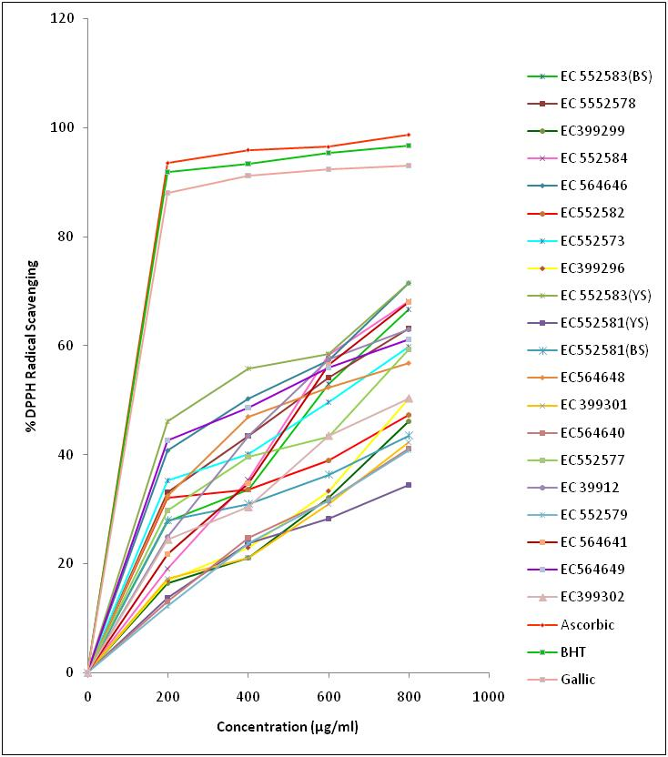Fig. 1. DPPH radical scavenging activity in defatted meal of exotic collections of Indian mustard

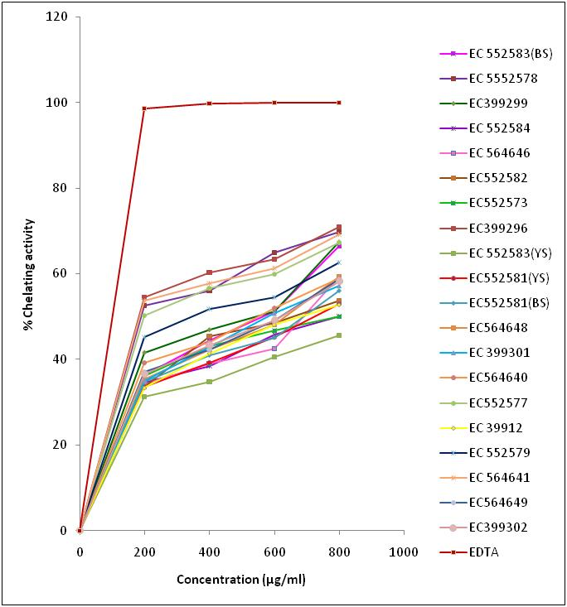 Fig. 2. Metal chelating activity in defatted meal of exotic collections of Indian mustard

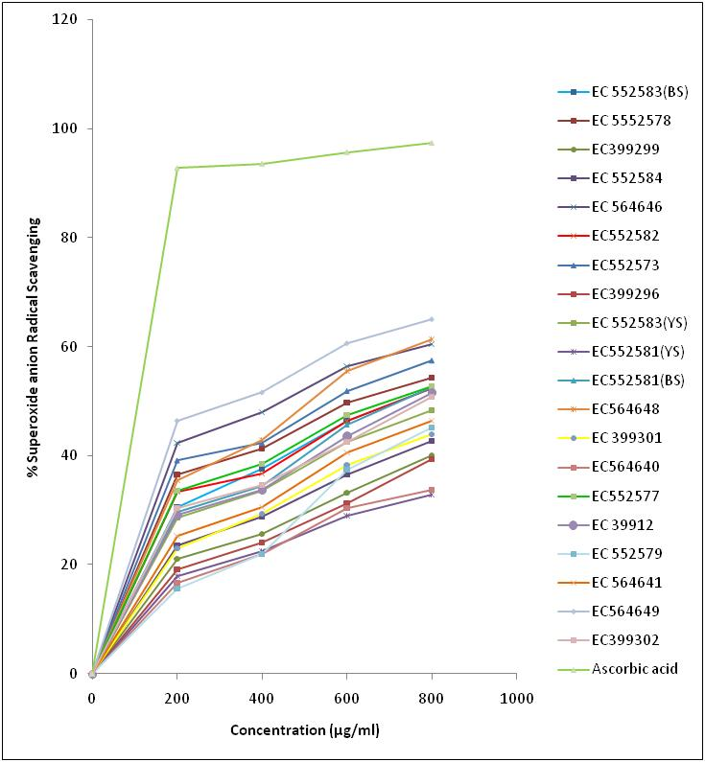Fig.3. Superoxide radical scavenging activity in defatted meal of exotic collections of Indian mustard

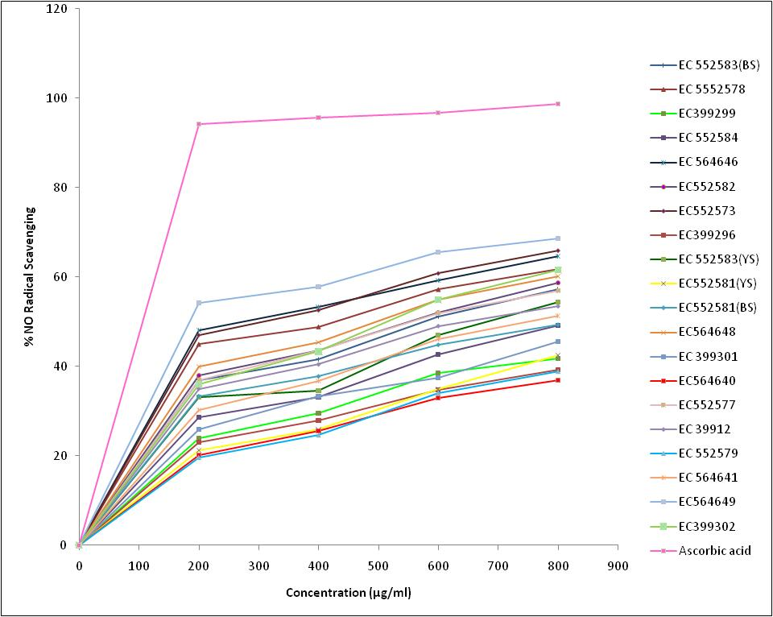 Fig. 4. Nitric oxide activity of defatted meal in exotic collections of Indian mustard

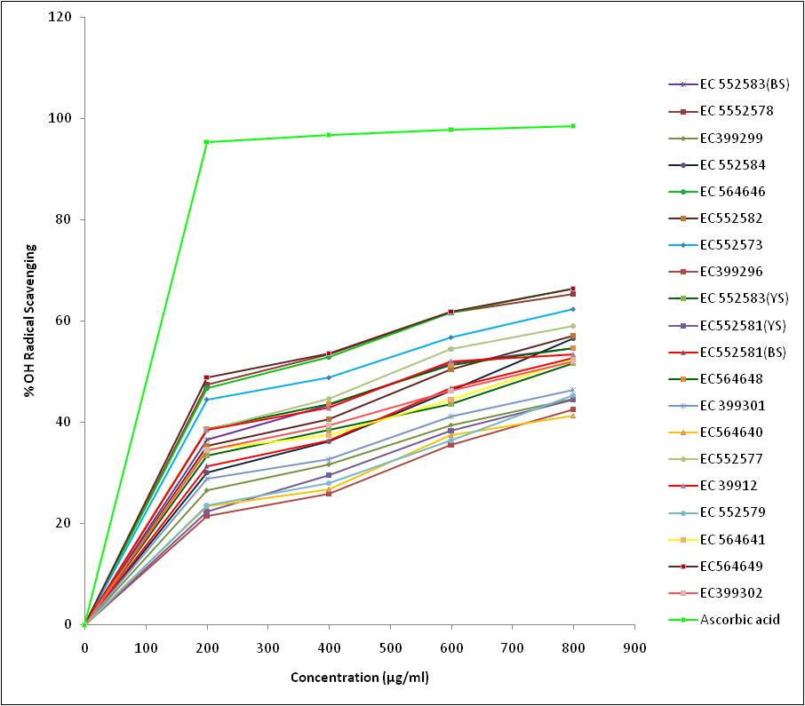
Fig. 5. Hydroxy radical activity in defatted meal of exotic collections of Indian mustard

