THE EXTENT OF GENETIC DIVERSITY AMONG POPULAR RICE CULTIVARS OF ANDHRA PRADESH AND TELANGANA USING MICROSATELLITE MARKERS
CH.V. Durga Rani ¹*, S Vanisri ¹*, Jamaloddin Mohammed¹*, Swathi Gattu¹*,
Ramprasad Eruvuri, Hadassah Gunti, Lakshminarayana R Vemireddy
¹*Contributed equally

ABSTRACT
Genetic diversity among 35 rice varieties developed and released by six at different Rice research stations of ANGRAU and PJTASU. viz., Rice Research Unit (RRU), Bapatla; Andhra Pradesh Rice Research Institute (APRRI), Maruteru; Rice Section, Rajendranagar; Regional Agricultural Research Station (RARS), Warangal; RARS, Jagtial and Agricultural Research Station (ARS), Nellore was investigated using 68 hyper variable polymorphic microsatellite markers to have more insights into the varietal diversity for future selection strategies in development of tailor made rice varieties suitable to different ecological niches of the state. In 68 polymorphic markers, a total of 298 alleles were detected with a range of 2 to 13 with an average allele number (Na) of 4.3 per locus. The Polymorphic Information Content (PIC) values ranged from 0.36 (RM24015) to 0.97 (RM 25310) with an average of 0.85. Overall estimation of number of alleles (Na) and genetic diversity index (He) indicated low to moderate level of diversity among the cultivars and research station wise estimation on number of alleles (Na) and genetic diversity index (He) clearly indicated that the varieties developed from Rajendranagar varieties exhibited maximum while, Nellore varieties with minimum followed by jagtial and varieties from remaining stations showed moderate values for both the parameters. The cluster analysis grouped all the varieties into six clusters.
Institute of Biotechnology, Prof. Jayashankar Telangana State Agricultural University, Rajendranagar, Hyderabad-500 030, India.
*Corresponding author: vanisree_dhar@yahoo.com
The cultivars developed from Rajendranagar, Maruteru and Warangal tends to group together and the remaining stations varieties are clustered in different groups for example the varieties viz., JGL3844, BPT4358, BPT2231 and BPT 5204 were placed in the Nellore group. The results of this study revealed that genetic diversity among the varieties released from different research stations is moderate and thus warrants the breeders of particularly ARS, Nellore and RARS, Jagtial to broaden the genetic base by selecting divergent parents while making crosses.
Key words: Rice, hyper variable microsatellite markers, polymorphism, diversity analysis
INTRODUCTION:
Rice is a key staple food for more than one third of the global population and endowed with rich genetic diversity (Chakravarthi and Naraveni, 2006). In India, Andhra Pradesh and Telangana states are placed among the top paddy producing states. Andhra Pradesh (combined) produced 127.62 lakh metric tons (MT) of paddy for the year of 2013-2014. The Acharya N.G Ranga Agricultural University (ANGRAU) Hyderabad, Andhra Pradesh and Prof. Jayashankar Telangana State Agricultural University (PJTSAU), Telangana played a vital role in Indian agriculture by releasing many high yielding rice varieties, that is evident from the fact that they the 4 mega varieties released from ANGRAU and PJTSAU viz; Swarna, BPT-5204, MTU1010 and MTU-1001, which occupied more than 25% of the rice growing area of the country. The important major rice research centers of ANGRAU and PJTSAU are Andhra Pradesh Rice Research Institute (APRRI), Maruteru, Rice Section, Rajendranagar, Hyderabad; Regional Agricultural Research Station (RARS), Warangal; Agricultural Research Station (ARS) Nellore; Rice Section, Rajendranagar; Rice Research Unit (RRU), Bapatla and Regional Agricultural Research Station (RARS), Jagtial. These six research stations contributed enormously to the rice research and released many popular rice varieties of promise to suit the preferences of different consumer groups of Andhra Pradesh, Telangana and India as well.
A systematic study of estimation of genetic diversity is worthy for identifying genetic divergence among the varieties, landraces, breeding lines and germplasm which in turn helps in development of tailor made designer rice varieties. Understanding of genetic diversity of popular cultivated rice varieties is important for broadening the genetic base. As of now previous research on the genetic diversity of rice mostly focused on inclusion of wild, japonica and indica cultivars and improved other general varieties in breeding programmes. But till now, there is no systematic and comprehensive attempt was made to assess the extent of genetic diversity among the rice varieties released from ANGRAU and PJTSAU which will be of great significance for their use of in future rice breeding programme.
Molecular markers have demonstrated potential to detect genetic diversity in plant genetic resources (Ford-Lloyd et al., 1997; Song et al., 2003). Wide applicability of molecular markers especially microsatellites in agriculture prompted us to choose SSRs to assess the genetic diversity among these rice cultivars. SSRs (McCouch et al., 1997) markers are useful for assessing the variability and diversity at molecular level (Joshi et al., 2000). Microsatellite markers are PCR- based markers that are technically very efficient and cost effective to use and are abundantly available for rice (Chen et al. 1977; Temnykh et al., 2000). In the present study 75hvSSR markers were used (Narshimulu et al., 2011) to detect the genetic diversity among the 35 popular rice varieties released from six different research stations of from ANGRAU and PJTSAU.
MATERALS AND METHODS
Plant material:
The experimental material comprised of 35 rice cultivars (Table 1) that were developed at six different research stations of ANGRAU and PJTSAU viz., Rice Research Unit (RRU), Bapatla; Andhra Pradesh Rice Research Institute (APRRI), Maruteru; Rice Section (RS), Rajendranagar; Regional Agricultural Research Station (RARS), Warangal; Regional Agricultural Research Station (RARS), Jagtial and Agricultural Research Station (ARS), Nellore. For collection of leaf samples and DNA extraction, 10 seeds from breeder seed lots of each of the 35 varieties collected from the corresponding research stations were grown and leaf samples of young seedlings were collected after 25 days and kept at -80°C.
Genomic DNA isolation:
Nucleus seed of 35 rice genotypes were allowed for germination in petridishes and 3-4 gm of leaf samples were collected from 7 days old seedlings and DNA was isolated following the modified CTAB (Cetyl Try Methyl Ammonium Bromide) method (Murray and Thompson, 1980). The quality and quantity of DNA was estimated in 0.8% agarose gel with lamda (λ) Hind III DNA as standard. Based on the intensity and thickness of genomic DNA bands, as compared to lamda (λ) Hind III DNA, the concentration and quality of DNA in individual samples were determined. After assessing the concentrations these samples were normalized in T₁₀E₁ buffer (10 mM Tris-HCl, 1 mM EDTA, pH 8.0) to get final concentration of 5 ng/ µl for amplification using microsatellite markers.

Microsatellite Markers and PCR amplification:
A set of 75 hyper variable rice microsatellite (hvRMs) markers, covering all the 12 chromosomes, were selected from the literature cited by (Narshimulu et al., 2011) to determine the genetic diversity among the 35 rice cultivars used in the present study. Polymerase Chain Reactions were done in a volume of 10 μl containing 10 x PCR Buffer, 2 mM each of the dNTPs, 5 pmol of each farward and reverse primer, 0.5 unit of Taq DNA polymerase (Genei, Bangalore, India), 10 ng/2µl template DNA. Amplification were carried out in GenAmp PCR system 9700 (Applied Biosystem, USA) thermal cycler with the following thermal profile: initial denaturation step at 94ºC for 5 min followed by 35 cycles at 95ºC for 45 sec, 57ºC for 45 sec, and 72ºC for 45 sec and a final cycle at 70ºC for 10 min. The amplified PCR products were mixed with bromophenol blue and run on a 3% agarose gel along with the 50-bp DNA ladder (New England Biolabs) in 0.5x Tris-Acetic acid EDTA (TAE) buffer. After two hours the gel containing DNA fragments were visualized under UV-Transilluminator and documented using Bio-Rad Molecular Imager Gel Doc XR System.
Data analysis:
Only clear and unambiguous bands of SSR markers were scored. The sizes of the amplified fragment were estimated with the help of Bio-Rad Molecular Imager Gel Doc XR System using 50 bp DNA ladder (NEB) as size standard. The amplified bands/alleles were scored as present (1) or absent (0) for each genotype and primer combination. To measure the informativeness of the markers, polymorphism information content (PIC) for each of the SSR markers was computed according to the formula: PIC =1− ∑ pi², Where pi is the frequency of the i^{th} allele of each locus (Botstein et al., 1980).
Genetic diversity parameters viz., number of alleles (Na), Shannon Index (I) and Nei’s genetic diversity index (He) (Nei M et al 1973) were evaluated using POP-GENE version 1.31 (http://www.ualberta.ca/,fyeh). The UNJ (Un Weighted neighbor joining Method) cluster analysis followed by boost strap analysis with 1000 per mutations for total cultivars was carried out using DARwin 5.0.145 (http://darwin.cirad.fr/).
RESULTS AND DISCUSSION
Allelic diversity of microsatellite markers in rice cultivars:
Out of 75 hvRM markers, 7 primer pairs were monomorphic and 68 were polymorphic (90.6% polymorphism). A total of 298 bands/alleles were detected in all 35 cultivars with 68 polymorphic markers. The overall number of alleles per locus ranged from 2 to 13 with an average of 4.38 (Table 2,3,4). This was significantly higher than the average of number of alleles reported by Sajib et al. (2012) (3.3). This higher value in the present study (4.38) could probably be as a result of existence of higher diversity among the cultivars. However, the number of alleles detected in the present study was lower than the average number of alleles reported by Xu et al. (2004), (11.9) Jain et al. (2004) (7.8), Zeng et al. (2007) (7.7) and Speda et al. (2004) (7.2). One locus namely, RM21881pocesses highest number alleles (13). The lowest number of alleles were observed in RM24481, RM11340 and RM11597 loci (2 in each case) and of the all 68 loci, 20 were with 3 alleles, 19 were with 4 alleles, while 15 loci with 5alleles. Loci with 3 alleles are more frequent followed by 4 and 5 alleles (Fig. 1). The number of alleles detected by a single SSR locus varied from 1 to 31 depending upon the fingerprinting techniques and materials used in the studies (Ni et al., 2002; Blair et al., 2002; Lu et al., 2005; Jayamani et al., 2007; Thompson et al., 2009; Kaushik et al., 2011). In the present study microsatellite markers with simple di-nucleotide repeat motifs detected a greater number of alleles (average: 4.552) (Table 2) than those with tri-nucleotide and tetra nucleotide repeat motifs (average: 4.39 and 3.50 respectively) (Table 3 and 4). Similar observations are also made by Cho et al. (2000) and Jain et al. (2004). Significant positive correlation (r = 0.105) was found between number of alleles amplified per locus and number of repeats in simple motif of a SSR locus (Table 5) in the present study. Ni et al. (2002) and Yu et al. (2003) also found positive correlation between number of alleles amplified and number of repeats within a microsatellite marker. The overall He values ranged from 0.23 (RM11597) to 0.89 (RM21881) (table 2,3) with an average of 0.60 and more than 40% of the loci were in the frequency of 0.5- 0.6. The overall average He values (Genetic diversity index) of the present study are slightly higher than the earlier studies (Gangaprasad chowdary et al. 2013). The research station wise estimation of number of alleles (Na) and He values (Genetic diversity index) clearly indicated that the varieties released from Rice Section, Rajendranagar exhibited maximum no. of alleles (3.0145) and genetic diversity index (0.5097), followed by Bapatla (Na: 2.6522, He: 0.4264), Maruteru (Na: 2.5072, He: 0.4184), Warangal (Na: 2.0725 He: 0.3664) and Jagtial (Na: 1.971, He: 0.2965) (Table 4 and Fig 2). While, Nellore varieties exhibited minimum no. of alleles (1.6087) and genetic diversity index (0.2609) values. These low values for Nellore cultivars might be due to the inclusion of only two popular varieties from this station for this study.
Polymorphism information content of microsatellite markers:
The Polymorphism information content (PIC) values provides an estimates of discriminating power of a marker based on the number of alleles at a locus and relative frequencies of these alleles. The PIC values for 68 SSR loci in our study varied from 0.36 (RM24015) to 0.97 (RM 25310) with an average of 0.85 and more than 50% loci in the range of 0.8 - >9.0 (Fig. 1). The estimated average PIC values are relatively higher than the average PIC values as reported by others (Lu et al., 2005; Juneja et al., 2006; Joshi et al., 2010) and thus might be due to higher genetic diversity present among the selected rice cultivars. Moreover, the SSR markers used in the study were selected on the basis of their high PIC values reported earlier (Narshimulu et al., 2011). Microsatellite markers with simple di-nucleotide repeat motifs detected higher polymorphism (Mean: 0.866) than those with tri and tetra nucleotide repeat motifs (Mean: 0.85 and 0.77) (Table 2, 3 and 4). Positive correlation (r = 0.0832) was observed between number of repeats of simple motif and PIC value of a SSR locus. Jain et al. (2006) had also observed that PIC values showed a positive correlation with total number of alleles at SSR locus (P = 0.01). Microsatellite loci with AT-rich di, AAT rich tri-and AGAT rich tetra nucleotide repeat motifs amplified a greater number of alleles and revealed greater polymorphism (Table 2, 3 and 4). One of the microsatellite markers, RM 25310 having (AT)_{n} repeats amplified 11 alleles and had PIC values of 0.97.
Genetic diversity among popular rice cultivars of Andhra Pradesh and Telangana:
The un-weighted neighbor joining (UNJ) dendrogram was constructed based on polymorphism data of the 68 hvRMs. In dendrogram Green lines indicated varieties from Rajendranagar, Blue line indicated varieties from Bapatla, Yellow line indicated varieties from Warangal, Brown line indicated varieties from Jagtial, Pink line indicated varieties from Nellore and red line indicated varieties from Maruteru (Fig 3). The 35 rice cultivars brought from different rice research stations of ANGRAU and PJTSAU were broadly divided into six clusters. The cultivars developed from Rajendranagar, Maruteru and Warangal tend to group together into individual groups. The key reason for their distinct station wise separation can be attributed to the fact of sharing similar parentage or pedigree for the development of varieties within the research stations. As an example, all seven varieties studied from APRRI, Maruteru showed less diversity as they involved either one or both the parents released from the same research station. Using of same station varieties continuously for many years decreased the genetic diversity among themselves. However, the varieties viz., JGL3844, BPT4358, BPT2231 and BPT 5204 were placed in the Nellore group cluster but these varieties do not share the common parentage or pedigree. This might be due to presence of similar alleles corresponds to respective microsatellite loci. Compared to all rice research stations, rice varieties released from Rice section; Rajendranagar found to have more number of alleles and more genetic diversity followed by Rice Research Unit, Bapatla, while, ARS, Nellore varieties showed least genetic diversity.
Conclusions:
In conclusion the present study clearly indicated that a low to moderate genetic diversity existed among popular rice cultivars of Andhra Pradesh and Telangana. All the cultivars analyzed could be distinguished from each other. However, this present study warrants the breeders of all research stations of Andhra Pradesh (ANGRAU) and Telangana (PJTSAU) except Rajendranagar, Particularly ARS, Nellore and RARS, Jagtial to broaden the genetic base of their parental varieties while planning the future rice breeding programmes by including divergent rice accessions from japonica, javonica, landraces and wild/weedy species.
Acknowledgements:
We thank the breeders of different rice breeding centres for sharing the seed materials of respective varieties.

References:
Blair MW, Hedetale V, McCouch SR (2002) Fluorescent labeled microsatellite panels useful for detecting allelic diversity in cultivated rice (Oryza sativa L.). Theor Appl Genet. 105:449-457
Botstein, D.; White, K. L.; Skolnick, M. and Davis, R. W. (1980): Construction of a genetic linkage map in man using restriction fragment length polymorphisms. Am. J. Hum. Genet. 32: 314-33l .
Chakravarthi B K and Naravaneni R. 2006. SSR marker based DNA fingerprinting and diversity study in rice (Oryza sativa L). African J Biotechnol., 5(9): 684-688.
ChenMP, Sanmiguel AC, De Oliveira, Woo S‐S, Zhang H, Wing RA, Bennetzen J.1997. Microcolinearity in sh2‐homologous regions of the maize, rice, and sorghum genomes. Proceedings of the National Academy of Sciences of the USA 94: 3431–3435.
Cho YG, Ishii T, Temnykh S, Chen X, Lipovich L, McCouch SR (2000) Diversity of microsatellites derived from genomic libraries and Gene Bank sequences in rice (Oryza sativa L.). Theor Appl Genet. 100:713-722
Choudhary G, Ranjitkumar N, Surapaneni M, Deborah DA, Vipparla A, et al. (2013) Molecular Genetic Diversity of Major Indian Rice Cultivars over Decadal Periods. PLoS ONE 8(6): e66197. doi:10.1371/journal.pone.0066197
Jain S, Jain RK, McCouch SR (2004) Genetic analysis of Indian aromatic and quality rice (Oryza sativa) germplasm using panels of fluorescently-labeled microsatellite markers. Theor Appl Genet. 109:965-977
Jain S, Jain RK, McCouch SR. 2004. Genetic analysis of Indian aromatic and quality rice (Oryza sativa L.) germplasm using panels of fluorescently-labeled microsatellite markers. Theor. Appl. Genet., 109(5): 965-977.
Jayamani P, Negrao S, Martins M, Macas B, Oliveira MM (2007) Genetic relatedness of Portuguese rice accessions from diverse origin as assessed by microsatellite markers. Crop Sci. 47:879 – 886
Joshi RK, Subudhi E, Kar B, Nayak S (2010) Comparative genetic analysis of lowland rice cultivars of India using microsatellite markers. Biores Bull. 4: 213- 223
Joshi, H., Wiggins, R.D., Bartley, M., Mitchell, R., Gleave, S., Lynch, K., 2000. Putting health inequalities on the map: does where you live matter, and why? In: Graham, H. (Ed.), Understanding Health Inequalities. Open University Press, Buckingham, pp. 143–155
Juneja S, Das A, Joshi SV, Sharma S, Vikal Y, Patra BC, Bharaj TS, Sidhu JS, Singh K (2006) Oryza nivara Sharma et Shastry, the progenitor of O. sativa L. subspecies indica harbours rich genetic diversity as measured by SSR markers. Curr Sci. 91:1079-1085
Kaushik A, Jain S, McCouch SR, Jain RK (2011) Phylogenetic relationships among various groups of rice (Oryza sativa L.) as revealed by microsatellite and transposable element-based marker analysis. Indian J Genet Pl Br 71:139-150
Lu H, Redus MA, Coburn JR, Rutger JN, McCouch SR, Tai TH (2005) Population structure and breeding patterns of 145 US rice cultivars based on SSR marker analysis. Crop Sci. 45:. 66-76
Mc Couch SR, Chen X, Panaud O, Temnykh S, Xu Y, Cho YG, Huang N, Ishii T, Blair M.1997. Microsatellite marker development, mapping and applications in rice genetics and breeding. Plant Molecular Biology 35: 89–99.
Murray, M.G. and W.F. Thompson, 1980. Rapid isolation of high molecular weight plant DNA. Nuc. Acids Res. 8:4321–4325.
Narshimulu, G., Jamaloddin, M., Vemireddy, L.R., Anuradha, G and Siddiq, E.A. 2011. Potentiality of evenly distributed hyper variable microsatellite markers in marker-assisted breeding of rice. doi:10.1111/j.1439-0523.2010.01834.x
Ni J, Colowit PM, Mackill DJ (2002) Evaluation of genetic diversity in rice subspecies using microsatellite markers. Crop Sci. 42:601-607
Ni J, Colowit PM, Mackill DJ (2002) Evaluation of genetic diversity in rice subspecies using microsatellite markers. Crop Sci. 42:601-607
Sajib AM, Hossain MM, Mosnaz ATMJ, Hossain H, Islam MM, Ali MS, Prodhan SH (2012). SSR marker-based molecular characterization and genetic diversity analysis of aromatic landraces of rice (Oryza sativa L.). J. BioSci. Biotechnol. 1:107-116.
Song ZP, Xu X, Wang B, Chen JK (2003) Genetic diversity in the northernmost Oryza rufipogon populations estimated by SSR markers. Theor. Appl. Genet. 107: 1492-1499.
Speda, A., Mantegazza, R., Biloni, M., Caporali, E. and Sala, F. 2004 Italian rice varieties: Historical data, molecular markers, and pedigree to reveal their genetic relationships. Plant Breed. 123: 1005-1011
Temnykh S, Park WD, Ayres N, Cartinhour S, Hauck N, Lipovich L, Cho YG, Ishii T, McCouch SR.2000. Mapping and genome organization of microsatellite sequences in rice (Oryza sativa L.).Theoretical and Applied Genetics 100: 697–712.
Thomson MJ, Polato NR, Prasetiyono J, Trijatmiko KR, Silitonga TS, McCouch SR(2009) Genetic diversity of isolated populations of Indonesian landraces of rice (Oryza sativa L.), collected in East Kalimantan on the Island of Borneo. Rice. 2: 80–92
Xu YB, Beachell H, McCouch SR. 2004. A marker-based approach to broadening the genetic base of rice in the USA. Crop Sci., 44(6): 1947-1959.
Yu SB, Xu WJ, Vijayakumar CHM, Ali J, Fu BY, Xu JL, Jian YZ, Marghirang R, Domingo J, Aquino C, Virmani SS, Li ZK (2003) Molecular diversity and multi locus organization of the parental lines used in the International Rice Molecular Breeding Program. Theor Appl Genet. 108:131-140
Zeng Y, Zhang H, Li Z, Shen S, Sun J, Wang M, Liao D, Liu X, Wang X, Xiao F, Wen G. 2007. Evaluation of genetic diversity of rice landraces (Oryza sativa L.) in Yunnan, China. Breed. Sci., 57: 91-99.
Table 1. List of cultivars used for genetic diversity study in rice
S.No. | Genotypes | Pedigree | Year of Release | Research stations
1 | RNRC 28 | IR64X9994 | Pre released | Rice Section,  Rajendranagar
2 | Sugandha Samba | RNR19994/RNR M7 | 2010 | Rice Section,  Rajendranagar
3 | Chandan | SonaX Manoharsali | 1989 | Rice Section,  Rajendranagar
4 | Sumathi | ChandanXPak-basmati | 2002 | Rice Section,  Rajendranagar
5 | RNR 2354 | RNR M7/RNR 1994 | Minikit | Rice Section,  Rajendranagar
6 | Early Samba | Mutant of Samba Mahsuri | 1999 | Rice Section,  Rajendranagar
7 | RNR 2458 (Krishna) | Chandan X BPT 5204 | 2012 | Rice Section,  Rajendranagar
8 | RNR 23064 (Taramati) | Tellahamsa/ BPT 5204 | 2009 | Rice Section,  Rajendranagar
9 | Tellahamsa | HR12 X TN1 | 1971 | Rice Section,  Rajendranagar
10 | Satya | Tellahamsa X Rasi | 1989 | Rice Section,  Rajendranagar
11 | MTU1010 (Cottondora Sannalu) | Krishnaveni X IR 64 | 2000 | APRRI, Maruteru
12 | MTU 4870 (Deepthi) | Sowbhagya X ARC 6650 | 1997 | APRRI, Maruteru
13 | MTU 1075 (Pushyami) | PLA 1100 X MTU 1010 | 2006 | APRRI, Maruteru
14 | MTU 1061 (Indra) | PLA 1100 X MTU 1010 | 2006 | APRRI, Maruteru
15 | MTU 7029 (Swarna) | Vasista X Mahsuri | 2011 | APRRI, Maruteru
16 | MTU 1001 (Vijetha) | Vajram X MTU7014 | 1995 | APRRI, Maruteru
17 | MTU 1064 (Amara) | PLA 1100 X MTU 1010 | 2009 | APRRI, Maruteru
18 | JGL 384 (Polasaprabha) | Samba Mahsuri X Kavya | 2011 | RARS, Jagtial
19 | JGL 11470 (Jagtial Mahsuri) | JGL 418/ Gedongibeton | 2012 | RARS, Jagtial
20 | JGL 3855 (Karimnagar Samba) | BPT 5204/ARC5984//Kavya | 2012 | RARS, Jagtial
21 | JGL 1798 (Jagtial Sannalu) | Samba Mahsuri X Kavya | 2002 | RARS, Jagtial
22 | JGL 3844(Jagityal Samba) | Samba Mahsuri X ARC 5984 | 2010 | RARS, Jagtial
23 | NLR 145(Swarnamukhi) | CICA4/IR625-23-3-1//Tetep | 2011 | ARS, Nellore
24 | NLR 34449 (Nellore Mahsuri) | IR72 X Samba Mahsuri | 2010 | ARS, Nellore
25 | BPT 4358(Surya) | Sona Mahsuri X ARC6650 | 2000 | RRU, Bapatla
26 | BPT 5204(Samba Mahsuri) | GEB24/T(N)1//Mahsuri | 1986 | RRU, Bapatla
27 | BPT 2231(Akshya) | Surya X IR64 | 2010 | RRU, Bapatla
28 | BPT 2270 (Bhavapuri Sannalu) | Samba Mahsuri/CR15MR1523 | 2010 | RRU, Bapatla
29 | BPT 2295 | BPT 1768/NLR 33641 | 2012 | RRU, Bapatla
30 | BPT 3291(Sona Mahsuri) | SONA/Mahsuri | 1984 | RRU, Bapatla
31 | BPT 1768 (Bapatla Sannalu) | BPT 3301 X Mutant Mahsuri | 2003 | RRU, Bapatla
32 | WGL 14 (Warangalsamba) | Samba Mahsuri/ARC5984// BPT 3291 | 2005 | RARS, Warangal
33 | WGL 2047 (Erramallelu) | BC-5-55/W12708 | 1991 | RARS, Warangal
34 | WGL 32100 (Warangal Sannalu) | Divya X BPT 5204 | 2011 | RARS, Warangal
35 | WGL 48684 (Kavya) | WGL27120/WGL17672// Mahsuri/Surekha | 1991 | RARS, Warangal

Table 2. Details of di nucleotide repeat microsatellite markers used in the study besides their corresponding Na, PIC and He Values
S.No. | SSR Locus | Motif | Number of Repeats | Chr. No. | Number of alleles  (Na) | PIC Values | He Values  Genetic diversity index | I
1 | RM10167 | AT | 43 | 1 | 6 | 0.82 | 0.55 | 1.03
2 | RM12031 | AG | 48 | 1 | 3 | 0.83 | 0.51 | 0.85
3 | RM11340 | AT | 42 | 1 | 2 | 0.67 | 0.38 | 0.57
4 | RM11597 | AT | 42 | 1 | 2 | 0.61 | 0.23 | 0.40
5 | RM12292 | AT | 38 | 1 | 4 | 0.93 | 0.73 | 1.42
6 | RM13659 | AT | 50 | 2 | 7 | 0.94 | 0.73 | 1.51
7 | RM13131 | AT | 32 | 2 | 5 | 0.92 | 0.64 | 1.18
8 | RM15679 | AC | 59 | 3 | 4 | 0.81 | 0.37 | 0.72
9 | RM15630 | AG | 55 | 3 | 3 | 0.80 | 0.42 | 0.72
10 | RM15580 | AT | 50 | 3 | 5 | 0.93 | 0.64 | 1.18
11 | RM15831 | AT | 57 | 3 | 4 | 0.85 | 0.58 | 1.00
12 | RM14778 | AT | 37 | 3 | 4 | 0.92 | 0.69 | 1.29
13 | RM14270 | AT | 46 | 3 | 4 | 0.85 | 0.61 | 1.09
14 | RM16153 | AC | 56 | 3 | 3 | 0.81 | 0.46 | 0.73
15 | RM15379 | AT | 46 | 3 | 3 | 0.82 | 0.49 | 0.81
16 | RM18939 | AT | 46 | 5 | 4 | 0.93 | 0.72 | 1.34
17 | RM18704 | AT | 47 | 5 | 5 | 0.90 | 0.67 | 1.25
18 | RM20710 | AT | 46 | 6 | 6 | 0.93 | 0.76 | 1.58
19 | RM20583 | AT | 46 | 6 | 5 | 0.83 | 0.74 | 1.47
20 | RM21693 | AT | 44 | 7 | 6 | 0.95 | 0.73 | 1.51
21 | RM23237 | AC | 57 | 8 | 4 | 0.90 | 0.60 | 1.12
22 | RM22273 | AT | 35 | 8 | 3 | 0.84 | 0.55 | 1.09
23 | RM24542 | AT | 51 | 9 | 3 | 0.86 | 0.60 | 0.98
24 | RM25453 | AT | 45 | 10 | 5 | 0.94 | 0.72 | 1.37
25 | RM25310 | AT | 42 | 10 | 11 | 0.97 | 0.86 | 2.18
26 | RM25355 | AT | 60 | 10 | 6 | 0.92 | 0.76 | 1.56
27 | RM26109 | AT | 45 | 11 | 3 | 0.82 | 0.50 | 0.74
28 | RM27323 | AT | 47 | 11 | 7 | 0.92 | 0.77 | 1.61
29 | RM28067 | AT | 48 | 12 | 5 | 0.92 | 0.62 | 1.18
Total |  |  |  |  | 132 | 25.14 | 17.63 | 33.48
Mean |  |  |  |  | 4.551 | 0.866 | 0.607 | 1.154

Table 3. Details of tri nucleotide repeat microsatellite markers used in the study besides their corresponding Na, PIC and He Values
S.NO | SSR Locus | Motif | Number of Repeats | Chr | Number of alleles  (Na) | PIC Values | He Values  Genetic diversity index | I
1 | RM11111 | AAT | 31 | 1 | 3 | 0.80 | 0.58 | 0.96
2 | RM11229 | AAT | 42 | 1 | 6 | 0.85 | 0.77 | 1.63
3 | RM10886 | AAG | 13 | 1 | 3 | 0.84 | 0.55 | 0.90
4 | RM11313 | AAT | 23 | 1 | 4 | 0.88 | 0.53 | 0.97
5 | RM12690 | AAT | 42 | 2 | 3 | 0.53 | 0.61 | 1.01
6 | RM13154 | AAT | 34 | 2 | 3 | 0.80 | 0.43 | 0.77
7 | RM13238 | AAT | 49 | 2 | 5 | 0.94 | 0.72 | 1.38
8 | RM12353 | AAT | 26 | 2 | 3 | 0.84 | 0.54 | 0.86
9 | RM13155 | AAC | 39 | 2 | 3 | 0.87 | 0.54 | 0.89
10 | RM13867 | AAT | 34 | 2 | 5 | 0.72 | 0.69 | 1.33
11 | RM16006 | AAT | 80 | 3 | 3 | 0.85 | 0.59 | 0.96
12 | RM14250 | AAT | 41 | 3 | 5 | 0.93 | 0.70 | 1.33
13 | RM15626 | AAT | 39 | 3 | 6 | 0.90 | 0.76 | 1.58
14 | RM16913 | AAT | 51 | 4 | 7 | 0.89 | 0.83 | 1.85
15 | RM19208 | AAT | 19 | 5 | 4 | 0.89 | 0.57 | 1.02
16 | RM18639 | AAT | 17 | 5 | 4 | 0.92 | 0.68 | 1.25
17 | RM18384 | AAG | 22 | 5 | 5 | 0.84 | 0.33 | 0.66
18 | RM20615 | AAT | 63 | 6 | 5 | 0.80 | 0.72 | 1.43
19 | RM21881 | AAT | 25 | 7 | 13 | 0.95 | 0.89 | 2.36
20 | RM21539 | AAT | 32 | 7 | 4 | 0.89 | 0.56 | 1.05
21 | RM20979 | AAG | 15 | 7 | 3 | 0.86 | 0.60 | 1.01
22 | RM23017 | AAT | 18 | 8 | 4 | 0.92 | 0.69 | 1.26
23 | RM23362 | AAG | 19 | 8 | 3 | 0.86 | 0.58 | 0.95
24 | RM23146 | AAT | 66 | 8 | 4 | 0.91 | 0.65 | 1.20
25 | RM22250 | AAT | 30 | 8 | 5 | 0.94 | 0.71 | 1.38
26 | RM22554 | AAT | 20 | 8 | 3 | 0.85 | 0.55 | 0.92
27 | RM22688 | AAT | 28 | 8 | 3 | 0.74 | 0.24 | 0.47
28 | RM24044 | AAG | 11 | 9 | 4 | 0.90 | 0.63 | 1.16
29 | RM23741 | AAT | 28 | 9 | 4 | 0.93 | 0.72 | 1.33
 | RM25408 | AAT | 22 | 10 | 4 | 0.88 | 0.56 | 0.93
 | RM25969 | AAG | 18 | 11 | 5 | 0.95 | 0.76 | 1.52
 | RM28800 | AAT | 32 | 12 | 5 | 0.95 | 0.75 | 1.44
 | RM27840 | AAT | 37 | 12 | 4 | 0.56 | 0.51 | 0.75
Total |  |  |  |  | 145.00 | 28.18 | 20.54 | 38.51
Mean |  |  |  |  | 4.39 | 0.85 | 0.62 | 1.17

Table 4. Details of tetra nucleotide repeat microsatellite markers used in the study besides their corresponding Na, PIC and He Values
S.NO | SSR Locus | Motif | Number of Repeats | Chr | Number of alleles  (Na) | PIC Values | He Values  Genetic diversity index | I
1 | RM10936 | AGAT | 37 | 1 | 4 | 0.84 | 0.46 | 0.84
2 | RM22565 | ACAT | 15 | 8 | 5 | 0.90 | 0.52 | 0.84
3 | RM23036 | AGAT | 15 | 8 | 4 | 0.90 | 0.67 | 1.19
4 | RM24015 | AGAT | 9 | 9 | 3 | 0.36 | 0.51 | 0.75
5 | RM24481 | AGAT | 23 | 9 | 2 | 0.74 | 0.48 | 0.67
6 | RM26190 | AGAT | 13 | 11 | 3 | 0.87 | 0.62 | 1.02
Total |  |  |  |  | 21.00 | 4.61 | 3.26 | 5.31
Mean |  |  |  |  | 3.50 | 0.77 | 0.54 | 0.89

Table 5: Correlation coefficients
S.No. | Attributes (Table) | Correlation coefficient (r)
1 | Number of repeats - Number of alleles | 0.105
2 | Number of repeats - Polymorphic information content | 0.0832
3 | Number of alleles - Polymorphic information content | 0.4426

Fig 1. Average allele number (Na), Polymorphic information content (PIC) and Genetic diversity index (He) among the six rice research station cultivars of ANGRAU and PJTASU.
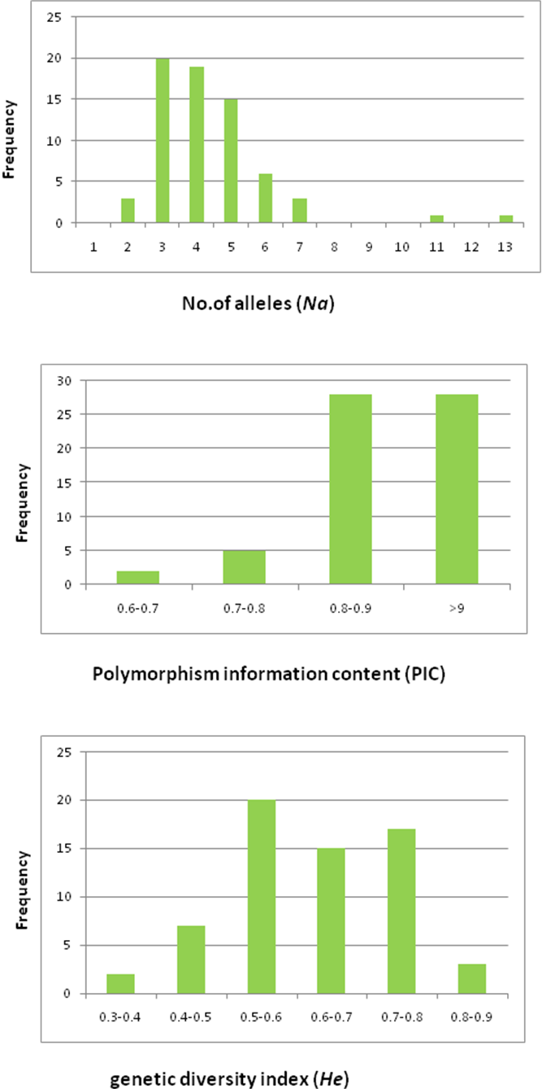
Fig 2a: Research stationwise number of alleles (Na) and expected heterozygosity or genetic diversity (He) of ANGRAU released rice varities.
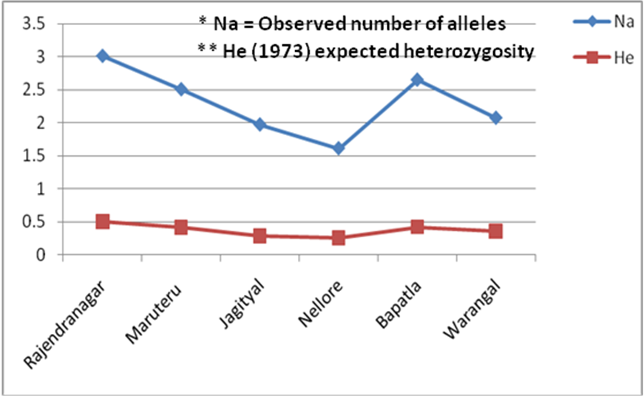

Fig 2b. Comparisons of average allele number (Na) and Genetic diversity index (He) among the six rice research station cultivars of ANGRAU and PJTASU.
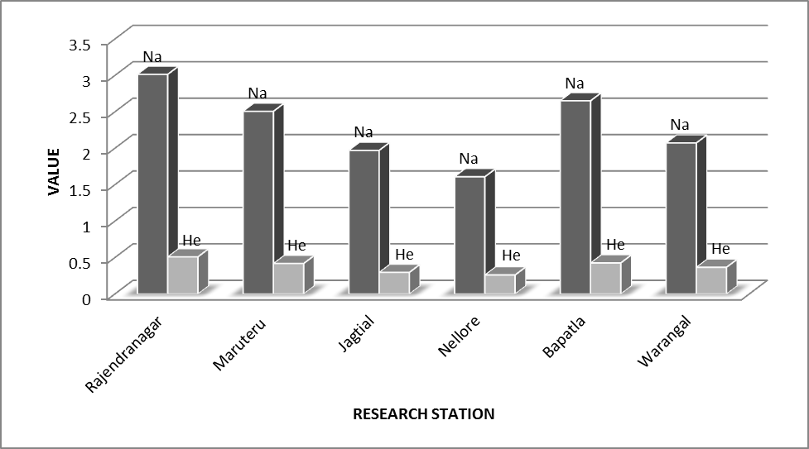

Fig 3. Un-weighted Neighbor Joining (UNJ) tree showing genetic relationship among 35 rice cultivars released from six rice research stations. Green: varieties from Rajendranagar, Blue: varieties from Bapatla, Yellow: varieties from Warangal, Brown: varieties from Jagtial, pink: varieties from Nellore, red: varieties from Maruteru.
