MICROSATELLITE BASED MUTANT CHARACTERIZATION FOR HIGH TILLERING ARCHITECT OF FOXTAIL MILLET VARIETY SRILAKSHMI
V.C.Khelurkar*¹, M.P.Moharil¹, K.P.Ingle¹, P.V.Jadhav¹, R.B.Ghorade², N.V.Kayande³, P.Suprasanna⁴
¹Biotechnology Centre, Department of Agricultural Botany, Dr. Panjabrao Deshmukh Krishi Vidyapeeth, Akola 444 104, India
²Sorghum Research Scientist, Department of Agricultural Botany, Dr. Panjabrao Deshmukh Krishi Vidyapeeth, Akola 444 104, India
³Department of Agricultural Botany, Dr. Panjabrao Deshmukh Krishi Vidyapeeth, Akola 444 104, India
⁴Plant Stress Physiology and Biotechnology Section, Nuclear Agriculture and Biotechnology Division, Bhabha Atomic Research Centre, Trombay, Mumbai 400 085, India
Corresponding author: Dr. M. P. Moharil
Biotechnology Centre, Dr. PDKV, Akola
mpmoharil@gmail.com, Ph. No. 9657725846

The present investigation targeted the foxtail millet Var. Srilakshmi for a high yielding attributes. The Variety Srilakshmi was irradiated with lethal dose of 400 Gy and post treated with 0.1% EMS at different time intervals of 6,12,18,24 hrs. The mutagenic concentration, (400 Gy + 18 hrs 0.1 % EMS) found to be the best which leads significant increase in tiller and panicle number. The molecular profiling of selected promising mutants for tillering architect were then characterized using 27 SSR primers with 17.33 % polymorphism, PIC (Polymorphic Information Content) value ranged from 0.37 to 0.69 with an average value of 0.31 and marker named SiGMS 12845 showed 100% polymorphism. The dendrogram was constructed based on SSR’s profiling and mutants were grouped into three cluster. The SSR’s markers were found to be helpful to determining the genetic diversity among mutants.
Keywords: Foxtail millet, EMS mutagen, SSR- Simple Sequence Repeat, cluster analysis, Dendrogram.
Introduction:
Foxtail millet Setaria italica (L) is an autogamous C₄ Panicoideae crop sp (Li and Brutnell 2011). It is an excellent experimental model system due to its relatively small genome ~515 Mb and chromosome 2n=18, low amount of repetitive DNA, inbreeding nature and short life cycle (Doust et al., 2009). It was reported that cereal grain plays an significant role in human diet thought out the world (Nanzi and Shobhana 2016). The Foxtail millet grain rich in protein (112 g/100gm), iron 28 mg/100mg, fat 4 gm/100 gm and it is a good source of the ß-carotene which is a precursor of vitamin-A (Murgun & Nirmalakumari, 2006). It has low glycemic index and hence referred as diabetic rice (Thathola et al., 2010).
Conventional plant breeding could be developed high yielding varieties using back crossing the new plants with original plants to keep the desired trait, linkage drag and inbreeding depression is the limitation. In foxtail millet artificial hybridization and recombinant breeding for varietal improvement could not be taken up because of small floret mutation breeding method which can be applied to the enhance the variability for qualitative and quantitative trait in number of crop plant, (Shu et al., 2009). Mutagenesis technique have also been integrated with molecular marker technique their by becoming more powerful and effective in crop breeding (Shu 2009). The present study targeted the Srilakshmi for molecular characterization of tillering architect. The genes responsible for high tillering architect reported as HTD1 (Zou et al.,2006), OsTB1(Minakuchi et al.,2010 and Guo et al., 2013), EATB(Qi et al.,2011. Molecular markers gives the precise information about extent of mutation and estimate genetic diversity at DNA level also facilitate the effective evolution of natural and induced genetic variability as well as their rational used in breeding programme.
Materials and Methodology:
Experimental Site:
The experiment was carried out during Kharif 2014 at the experimental field of department of Agricultural Botany, Dr Panjabrao Deshmukh Krishi Vidyapeeth, Akola, Maharashtra state, India. The soil was medium black with uniform in topography with appropriate drainage system.

Plant Materials:
The experimental material for the present investigation comprised of one genotype of foxtail millet (Setaria italica L) Foxtail millet Var. Srilakshmi procured from National Bureau of Plant Genetic Resources, Dr Panjabrao Deshmukh Krishi Vidyapeeth, Akola.The characteristics feature of Var. Srilakshmi listed in (Table 1).

Table 1: Characteristic feature of Var. Srilakshmi
SN | Pedigree | Pure line selection
1 | Centre/Institution developed | RARS, Nandyal, Andhra Pradesh
2 | Year of release | 2002
3 | Notification number and date | Central release
4 | Salient features | Semi compact panicles having a tuft of pink hairs at the top, medium sized grains
5 | Distinguishing morphological characters | Purple pigmented panicles
6 | Days to maturity | 80-85
7 | Reaction to biotic and abiotic stress | Resistant to downy mildew and rust, tolerant to moisture stress
8 | Recommended area/region/zone | All foxtail millet growing areas of the country
9 | Other special features | High grain yield
10 | Average grain yield (q/ha) | 23 – 25

Generation advancement
M₁ and M₂ Generations:
Five hundred seeds of foxtail millet Var. Srilakshmi were irradiated with 400 (Gy) gamma rays and 200 seeds were post treated with 0.1% of EMS for duration of treatment 6, 12, 18 and 24 hrs respectively. Untreated 100 seeds were also presoaked in distilled water for 4 hrs to raise the control population. The treated and control seeds were sown using dibbling method to raise M₁ generation M₁ selected plants were advanced to M₂ generation by taking 150-200 seeds from primary panicle of each

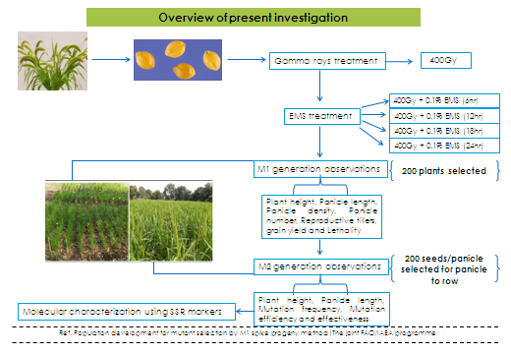

Fig 1: M₁ Spike Progeny Method for M₂ population development
selected plants using M₁ spike progeny method given by (The Joint FAO/IAEA Japan.) Figure 1 illustrated the M₁ spike Progeny Method for the development of M₂ generation.
Data collection:
Data on five randomly selected plants from each panicle were recorded for various traits Viz. plant height, reproductive tillers, grain yield, lethality, mutation frequency, mutation efficiency and effectiveness (Table 2) indicates the morphological characters that were undertaken during the present investigation.

Table 2: Phenotypic characters of M₂ population
Treatments | Plant height (cm) | Reproductive Tillers | Grain yield (gm/plant) | lethality | Mutation frequency | Mutagenic effectiveness | Mutation Efficiency
Control | 101 | 09 | 21 | 0 | 0 | 0 | 0
T1 | 45-90 | 12-13 | 28-36 | 54 | 80 | 0.041 | 1.48
T2 | 55-100 | 10-12 | 25-38 | 59 | 78 | 0.020 | 0.78
T3 | 50-111 | 10-15 | 31-45 | 70 | 85 | 0.014 | 1.21
T4 | 67-108 | 10-11 | 28-40 | 72 | 81 | 0.010 | 1.08

Molecular diversity studies:
DNA isolation and PCR amplification
DNA was extracted from 10 days old seedlings of promising mutants for targeting grain yield like low tillers, medium tillers and high tillers using CTAB method (Doyle and Doyle, 1990). The relative purity and concentration of extracted DNA were estimated with nanophotometer. The final concentration of each DNA samples were adjusted to 50 ng/ µl. Twenty seven SSR primers was used for the molecular characterization of selected mutants. The primers and their sequence along with melting temperature allelic size and their location in genome represented in (Table 3).
Table 3: Details of SSR markers used for the molecular characterization of mutants
Sr. No. | Marker | Repeat | Sequence | Tm | Product length | LG
1 | SiGMS203 | GA | F: GAGAGGAAGGGGAATGAAGG  TGGTATCCAAACACCCCCTA | 60.01  60.04 | 109 | 1
2 | SiGMS737 | CA | GCACACAACATCTAAGCCCC  CAGCAACTGGTGGTGGTG | 60.53  59.68 | 102 | 1
3 | SiGMS1515 | CT | CCCAAAATATTTCGTCCCCT  GCTCCGCTGTTCTACAAAGG | 60.01  60.02 | 118 | 1
4 | SiGMS1995 | CT | CAGTCGCAATTGTGCTCTGT  ACGATGTCCTCCAGCATCTT | 60.06  59.69 | 135 | 2
5 | SiGMS2453 | CT | GGAACGCCAAGCAACAGT  ACTCAGTAATCACGCGTCCC | 59.84  60.14 | 121 | 2
6 | SiGMS3543 | TG | AGGCGAGATCAGGAGGAACT  TGCTCACAATCAGTTAAAGCAA | 60.36  58.63 | 118 | 2
7 | SiGMS4069 | AT | ACCTCCCAAAATCAATAGCG  TTTGCATCTTGTTGTGGACG | 59.04  60.7 | 172 | 3
8 | SiGMS4882 | AT | AAGCAAAGTCTTCACAACCAAA  TCTTGAGTTTGGAGGGTGCT | 58.93  59.84 | 123 | 3
9 | SiGMS5586 | AC | GACAAGCCTCTTGTATTCCAGG  TCATGGGAAACCCATCCATA | 60.13  60.92 | 189 | 3
10 | SiGMS5726 | CA | CATCCAGCTGAACTGCAGAA  GGGAAGGAACGCTAAGGAAT | 60.14  59.55 | 142 | 4
11 | SiGMS6281 | GCG | TCCCCAGTTCTCACTGGTTC  CCAACGCTTCAAACCGTATT | 60.09  60.0 | 148 | 4
12 | SiGMS6938 | CT | AAATGGATGTGGACGACGAT  TGGTAACCGTACTGGCTGTG | 60.2  59.63 | 140 | 4
13 | SiGMS7002 | AT | CACTAGTGAGCTAGCAAGAACGA  TTGGTGATTGGCTTCAACTCT | 59.01  59.73 | 172 | 5
14 | SiGMS7828 | TG | CAATTTGGTGCTTGTGGATG  CCTCGACGACACTCCTAACC | 59.96  59.72 | 160 | 5
15 | SiGMS8985 | AT | TGGTTCTTGAAGTTGGCAGA  GCATTTTGATCACTATTTTGCAT | 59.42  58.21 | 163 | 5
16 | SiGMS9021 | CGG | GTACCCGAGCCCTTTCTCTC  CTGGTGGAGGAGACCAGCTA | 60.21  60.4 | 105 | 6
17 | SiGMS9551 | CAG | TGTGGTTGAGGTATCGGACA  TCACCCTCCTCTCTGCTGTT | 59.96  59.99 | 173 | 6
18 | SiGMS10184 | CGG | GCCTCAGAGGACGACGAC  ATCGGACGTGGACATGGTAT | 59.48  60.08 | 111 | 6
19 | SiGMS10256 | CGG | CTGAATCGGGCCAAGAAAC  ACTTCTTGCGCAGTGGAGG | 60.59  61.55 | 136 | 7
20 | SiGMS10547 | GGA | CACGCGCATGTGTTCTATTG  TTTCACAAAACCAGATCCCC | 60.27  59.77 | 125 | 7
21 | SiGMS11596 | CT | TTGGAAACTGACGTGTGTGG  CAGATGACTGTGCGTGGATT | 60.61  59.71 | 105 | 7
22 | SiGMS11633 | CAG | ACCGATCTCAAGATCATGCC  TCGGTGAAAACACATACGGA | 60.04  59.96 | 202 | 8
23 | SiGMS12150 | TGC | AAGGATCCGATGATTTGTGC  GCCAAGAAAATGGGGAAAAT | 59.9  60.13 | 162 | 8
24 | SiGMS12845 | AC | GACCGACACGGATCATACCT  AAAGATTCCTGGTCTACATCTCTGA | 59.81  59.69 | 105 | 8
25 | SiGMS14282 | TGC | CTGTTGAGTTTGTTGCGAGG  TTCCACAACCAAGACCACAA | 59.49  59.98 | 152 | 9
26 | SiGMS14792 | ACA | AAAACAAGACTTCTGGGGCA  TCAAACTTGCTTGGGACTGA | 59.71  59.42 | 133 | 9
27 | SiGMS14131 | CGT | CATGTCATTGTCAAGGGGC  CGTCCACGCTGTCGTCTT | 59.91  61.06 | 161 | 9

The PCR was performed in a final volume of 20 µl, containing 10X PCR buffer, 50mM Mgcl₂, 10 mM dNTP solution, 0.4mM of each primer and 50 ng genomic DNA and 1U Taq DNA polymerase. Each up the 40 PCR cycles consisted of 30 cycles at 94˚C for template denaturation, 30 cycles at 55˚C to 60˚C for primer annealing and 30 cycles at 72˚C for primer extension. The PCR reaction was completed with 5 minutes incubation at 72˚C. The PCR products were then separated on 8% PAGE.

Statistical Analysis:
Statistical Analysis was done using screening of all SSRs loci for each polymorphic amplicons as 1 for presence and 0 for absent. This allows estimating at each locus of the number of allele present and PIC. The PIC value of each primers were then calculated and similarity coefficient base on SSR profile were calculated according to procedure described by Sneath and Sokel (1978) and dendrogram based on the similarity matrix and UPGMA cluster was produced using the online software (XLSTAT).
Results and Discussion
Mean performance
Result suggested that treatment T₃ (400 Gy + 01% EMS, 18 hrs) was the best combination for observing the variation related to tillering architect (reproductive tillers), panicle number, panicle length, chlorophyll mutants and yield. The highest panicle length was observed in T₃ treatment (25 cm), panicle number (> 15), reproductive tiller (16), chlorophyll mutants (120) and yield per plant (35-40 gm) compared to Srilakshmi (T₀ treatment) having panicle length (8cm), panicle number (5), reproductive tiller (9), yield per plant (21 gm). Our results reflected the significant increase in panicle length as compared to control. Reproductive tillers are characterized by fully elongated stem and differentiation of the shoot apex in to the inflorescence. Each tiller has the potential to produce a grain head and thus it is important to have maximum tillers. High tillers generally accountable for high yield, similar results were reflected in our present investigation as increase in tiller number grain yield per plant also increased. Grain yield can also refer to the actual seed generation from the plant. In M₂ population screening, twenty one mutants have been identified for higher plant yield Treatment T₃ (400 Gy + 0.1% EMS, 18 hrs) shown the highest yield per plant (31-45 gm/plant). Our results reflected the considerable increase in grain yield/plant as compare to control (Srilakshmi) (Table 2).Thus it can conclude that grain yield was positively associated with reproductive tillers per plant, Sabesan et al (2009).

The mutagenic efficiency gives an idea of the proportion of mutation in relation to other associated undesirable biological effect such as injury, lethality and sterility induced by mutagen. Efficient mutagen and their treatment are indispensible for the cost effective use of the mutagen as a tool for the induction of mutations and their direct utilization in successful breeding programme. Considering the effect of combined treatment of gamma rays and EMS reflected the significant increase in macromutation frequency. Maximum mutational frequency was observed in treatment T₃ (400 Gy + 01% EMS, 18 hrs) ie 85%, followed by treatment T₄ (400 Gy + 0.1% EMS, 24 hrs) ie (81%) (data not shown). Singh et al., (2014) observed the similar results in lentil variety (HUL-57) by treating seeds with 10kR, 20kR and 30kR of gamma rays with 0.3% EMS concentration Considerable variation was observed in M₂ generation indicating the good effectiveness of the mutagen.

Molecular characterization of foxtail millet mutants using SSR markers based on tillering architect
In M₂ generation twenty thousand plants were screened for the mutation. Among these mutated population two hundred promising mutants were identified and phenotypically evaluated for the traits (dwarfness, short internode, stem girth, panicle density and yield attributing).Based on the morphological observations the five mutants were selected for the tillering architect comprising low tiller (R1-3/A-13), Medium tiller (R2-4/A-7 and R2-1/E-6), and high tiller (R2-1/D-12 and R2-5/A-6) and compared with control (Srilakshmi) for the molecular characterization of mutants. Tillering is one of the most important agronomic traits in cereal crops because tiller number per plant determines the number of spikes or panicles per plant, a key component of grain yield and biomass, Kuraparthy (2006).
Characteristics of SSR markers studied
Total twenty seven SSR primers were screened for the molecular characterization of the foxtail millet mutants as shown in (Table 3). The primers were scored as (1) for presence of allele and (0) for absence of alleles, polymorphic information content, percent polymorphism and monomorphic and polymorphic allele were enlisted in details in (Table 4).

Table 4: Characterization of foxtail millet mutants using SSR primers
S.N. | Primers | Total number of amplicon | Monomorphic alleles | Polymorphic alleles | PIC value | Percent polymorphism
1 | SiGMS203 | 1 | 1 | 0 | 0.00 | 0
2 | SiGMS737 | 1 | 1 | 0 | 0.00 | 0
3 | SiGMS1995 | 3 | 2 | 1 | 0.59 | 33
4 | SiGMS2453 | 1 | 1 | 0 | 0.00 | 0
5 | SiGMS3543 | 2 | 2 | 0 | 0.38 | 0
6 | SiGMS4069 | 3 | 1 | 2 | 0.69 | 66
7 | SiGMS4882 | 3 | 1 | 2 | 0.59 | 66
8 | SiGMS5586 | 1 | 1 | 0 | 0.00 | 0
9 | SiGMS6281 | 1 | 1 | 0 | 0.00 | 0
10 | SiGMS6938 | 2 | 2 | 0 | 0.38 | 0
11 | SiGMS7828 | 2 | 2 | 0 | 0.38 | 0
12 | SiGMS8985 | 2 | 2 | 0 | 0.38 | 0
13 | SiGMS9021 | 1 | 1 | 0 | 0 | 0
14 | SiGMS9551 | 2 | 2 | 0 | 0.37 | 0
15 | SiGMS10184 | 3 | 1 | 2 | 0.59 | 66
16 | SiGMS11596 | 1 | 1 | 0 | 0 | 0
17 | SiGMS11633 | 4 | 4 | 0 | 0.69 | 0
18 | SiGMS12150 | 3 | 3 | 0 | 0.59 | 0
19 | SiGMS12845 | 2 | 0 | 2 | 0.38 | 100
20 | SiGMS14282 | 3 | 2 | 1 | 0.59 | 33
21 | SiGMS14792 | 3 | 3 | 0 | 0.59 | 0
Total |  | 44 | 34 | 10 | 6.67 | 364
Average |  | 2.09 | 1.61 | 0.47 | 0.31 | 17.33

Among these primers, 15 were monomorphic, 6 were polymorphic and remaining 6 primers were not amplified. One primers SiGMS12845 shown 100% polymorphism, whereas, 66% polymorphism observed in SiGMS4069, SiGMS4882 and SiGMS10184, 33% polymorphism was detected in SiGMS1995 and SiGMS14282 and showed an average 17.33% polymorphism percent. Total alleles per locus were 2.09, whereas, average number of monomorphic and polymorphic alleles are 1.61 and 0.47, respectively The PIC (Polymorphic information content) of 21 microsatellite loci ranged from 0.37 to 0.69 with an average value of 0.31. For each markers the maximum PIC value was observed in marker SiGMS4069 and SiGMS11633 ie 0.69 and minimum was in SiGMS9551 ie 0.37. In a null allele frequencies analysis all microsatellite had null allele frequencies close to zero From (Table 4) it can be conclude that the primer SiGMS12845 showed 100% polymorphism percent and also 0.38 PIC value Similarly, the monomorphic and polymorphic amplicons is depicted in (Figure 2).
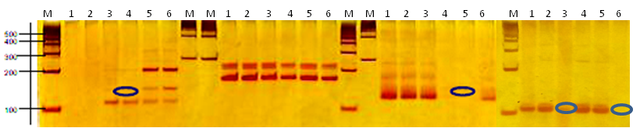
SiGMS 9551 SiGMS 10184 SiGMS 4882 SiGMS 12845

Fig 2: Monomorphic (SiGMS 9551) and polymorphic (SiGMS 10184, SiGMS 4882 and SiGMS 12845) nature of marker (1: Control (Srilakshmi), 2: Low tiller, 3 and 4: Medium tiller, 5 and 6: High tiller.

Genetic divergence studies

Based on similarity matrix and dendogram (Figure 3), cluster analysis (represented in Table 5) using morphological traits (tillering architect and panicle number) gouped the six genotypes in to four main clusters. It was also found that among the four clusters. cluster I includes control (Srilakshmi) and LT-1 (R1-2/ B-27) (low tiller) which shows the 100% similarity between them. The control and LT-1 mutant in this cluster had shown low number of tillers and low panicle density and panicle number. Cluster II includes only (R2-4/ A-7) MT-1 (medium tiller). The mutant in this cluster represented medium tiller numbers and medium panicle density and panicle number. Cluster III includes two mutants (R2-1/E-6) MT2 and (R2-1 /D-12) HT1 (high tiller). Among the two one represented for medium tillers and panicle numbers while other for high tiller and panicle numbers. Cluster IV cluster represent only one mutant (R2-5 / A-6) HT2 and has very high tiller and panicle numbers. Muduli and Das (2014) also showed the same results that the nature and magnitude of genetic divergence was estimated in 44 mutant lines of finger millet variety VR708, developed by single and combination treatments with gamma rays and EMS.

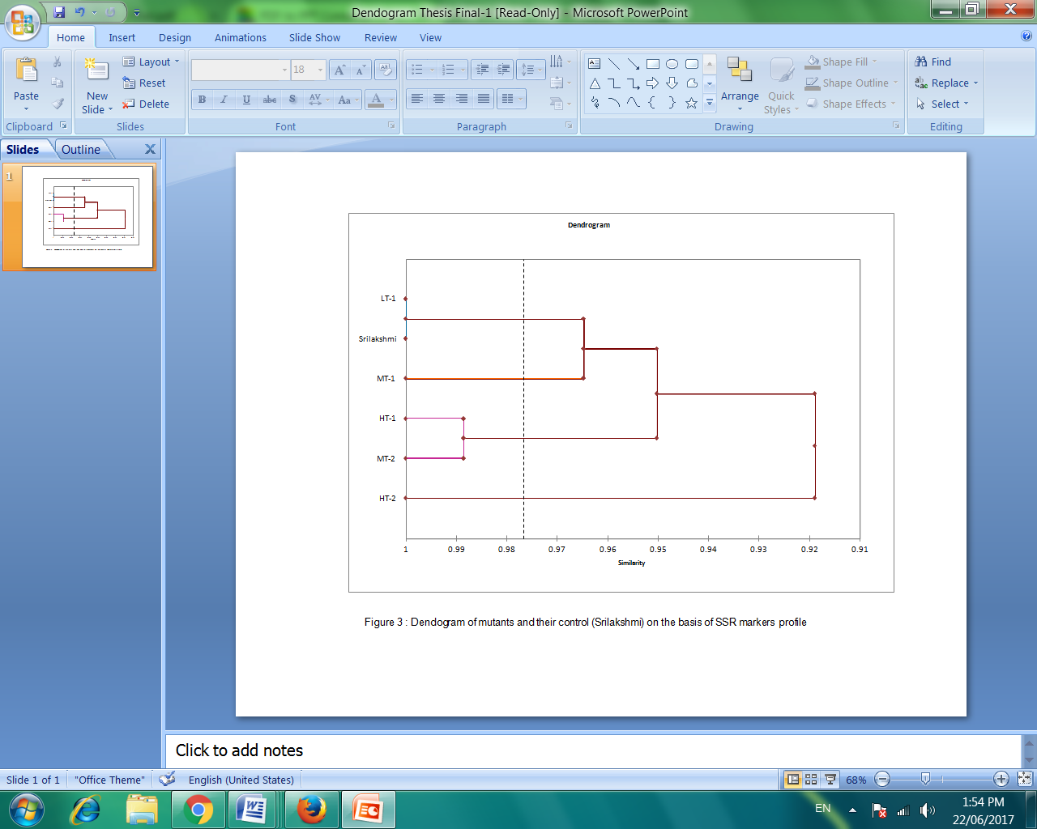
Fig 3: Dendogram of mutants and their control (Srilakshmi) on the basis of SSR profile
Table 5: Clusters analysis derived for SSR analysis
Group | Cluster | Mutants
1 | C1 | Srilakshmi (control)
1 | C1 | LT-1 ( R1-2/ B-27)
2 | C2 | MT-1(R2-4/ A-7)
3 | C3 | MT-2 (R2-1/E-6)
3 | C3 | HT-1 (R2-1 /D-12)
4 | C4 | HT-2 (R2-5 / A-6)

Conclusion:
The present investigation entitled “Molecular characterization of useful mutants of Foxtail millet (Setaria italica (L) Var. Srilakshmi” was under taken with the view to identify the promising mutants with respect to yield contributing traits. The genotype of Foxtail millet Var. Srilakshmi was irradiated with 400 Gy and 0.1% EMS as 50% lethality was observed at this treatment. Treated seeds were sown at experimental field of Department of Botany to rise M₂ generation. The phenotypic observations with respective to yield contributing traits such as plant height, panicle number and density, anthocyanin coloration of bristles, reproductive tiller, distance of third internode, lethality, mutation frequency and mutagenic effectiveness were carried out in both M₁ and M₂ generation. Based on the phenotypic evaluation 121 promising mutants with respective to yield contributing traits have been identified. The mutagenic concentration (400Gy+ 0.1% EMS, 18 hr treatment) resulted in significant increase in tiller numbers and panicle numbers and considered as best treatment among all and responsible for significant increase in yield attributing traits.
Promising mutants for tillering architect were subjected to molecular screening. Molecular characterization using SSR markers revealed considerable variability induced at various loci, targeted by SSR markers Amongst 27 SSR markers used, SiGMS 12845 showed 100% percent polymorphism.
The polymorphic marker identified in the present investigation for the characterization of promising mutants will be explored, in future, to see the association with any desired phenotype. However, point mutations cannot be or very rarely detected by the SSR marker, considering this different approaches like single stranded confirmation polymorphism (SSCP), Endonucleolytic Mutation Analysis by Internal Labelling (EMAIL), High resolution melting (HRM), Heteroduplex, should be used in future to investigate the important point mutation in functional gene.
Acknowledgment
The authors are grateful to Dr. Suprasanna Penna ,Principle Scientist and Project coordinator (Bhabha Atomic Research Centre, Mumbai), India for providing facilities for mutagenic treatments to undertake present investigation.
Future prospective:
The identified polymorphic marker in the present investigation will be explored in future to see the association with desired phenotype. Selective genotyping may be used for the screening of segregating population. Future study need to detect the point mutation using different approaches HRM (High Resolution Melting Point) and SSCP (Single Strand Conformational Polymorphism). Promising foxtail millet mutants will be advanced to next generation to obtain homogeneity and stability yield performance and other important phonological attributes can be studied after M₄ generation.
References:
Doust, A.N., Kellogg, E.A., Devos, K.M. and Bennetzen, J.L. 2009. Foxtail millet: a sequence-driven grass model system. Plant Physiology 149: 137–141
Guo, S., Xu, Y., Liu, H, Mao, Z., Zhang, C., Ma, Y., Zhang, Q., Meng, Z., and Chong, K . 2013. The interaction between OsMADS57 and OsTB1 modulates rice tillering via DWARF14 Nat Communication 4:1566-1572.
IAEA , 1994. 2014. Mutation Breeding of Oil Seed Crops Proceedings of a final Research Coordination Meeting of an FAO/IAEA Co-ordinated Research Program held in Vienna, Austria, 11-15 January 1993, IAEA-TECDOC-781. Joint FAO/IAEA Division of Nuclear Techniques in Food and Agriculture, Retrieved 31 July 2014
Kharkwal, M.C. and Shu Q.Y. 2009. The role of induced mutations in world food security In: Induced plant mutations in the genomics era Proceedings of the International Joint FAO/IAEA Symp IAEA, Vienna, p. 33–38.
Kuraparthy, V. Dhaliwal, H.S., Chhuneja P and Gill, B.S. 2007. Identification and mapping of a tiller inhibition gene (tin3) in wheat. Theoretical and Applied Genetics 114: 285–294.
Minakuchi, K., Kameoka H., Yasuno N., Umehara M., Luo L., Kobayashi K., Hanada A., Ueno K, Asami T., Yamaguchi, S, and Kyozuka, J. 2010. FINE CULM1 (FC1) works downstream of strigolactones to inhibit the outgrowth of axillary buds in rice. Plant Cell Physiology 51 (7) :1127–1135.
Muduli, K.C. and Das, T.R. 2014. Genetic Divergence among micromutants in finger millet (Eleusina coracana). Indian journal of Agricultural science 48: 313-318.

Murugan, R and Nirmalakumari, A. 2006. Genetic divergence in foxtail millet [Setaria italica (L) Beauv] Indian Journal of Genetics 66(4): 339-340.
Doyle, J.J. and Doyle, J.L. 1990. A rapid total DNA preparation procedure for fresh plant tissue. Phytochemical Bulletin 12 :13-15.
Qi, W., Sun, F., Wang, Q., Chen, M., Huang, Y., Feng, Y-Q, Luo, X. and Yang, J. 2011. Rice ethylene-response AP2/ERF factor OsEATB restricts internode elongation by down-regulating a gibberellin biosynthetic gene. Plant Physiology 157 (1):216–228.
Ram Narayan Ahirwar, Jay Prakash Lal and Prakash Singh. 2014. Gamma-rays and ethyl methane sulphonate induced mutation in Microsperma Lentil (Lens Culinaris L. Medikus) Supplement on Genetics and Plant Breeding 9 (2) : 791-795.
Sabesan, T., Saravanak, K. and Anandan, A. 2009. Genetic divergence analysis for certain yield and quality traits in rice (Oryza sativa L.) grown in irrigated saline low land of Annamalinagar, South India. Journal Central European Agriculture 10: 405-410.
Shobana Devi, R. and Nazni, P. 2016. Sensory Characteristics, Total Polyphenol Content and In vitro Antioxidant Activity of Value Added Processed Barnyard Millet Flour Chapattis. Journal of Food Processing & Technology 7: 595-602.
Shu, Q.Y. 2009. Induced Plant Mutations in the Genomics Era. Food and Agriculture Organization of the United Nations, Rome, p. 61-64.
Thathola, A., Srivastava, S. and Singh, G. 2010. Effect of foxtail millet (Setaria italica) supplementation on serum glucose, serum lipids and glycosylated hemoglobin in type 2 diabetics. Diabetologia Croatica 40 (1): 23-28.
Zou, J., Zhang, S., Zhang, W., Li, G., Chen, Z., Zhai, W., Zhao, X., Pan, X., Xie, Q. and Zhu, L. 2006. The rice HIGH-TILLERING DWARF1 encoding an orthologs of Arabidopsis MAX3 is required for negative regulation of the outgrowth of axillary buds. Plant Journal 48 (5):687–698.

