Introgression of durable rice blast resistance gene Pi-54 into an popular Indica Cv. Samba Mahsuri, through Marker Assisted Backcross Breeding programme

Vijay Kumar Sudarsanam, Rambabu Ratnala, Bhaskar Bajaru, Ratna Madhavi Kanaparthi, Srikanth Sabu, Prakasam Vellaisamy, Sundaram Raman Meenakshi, Sheshu Madhav Maganti, Subba Rao LellaVenkata and Srinivas Prasad Madamsetty*

*Corresponding author: data.msprasad@gmail.com;
ICAR-Indian Institute of Rice Research, Rajendranagar, Hyderabad - 500 030, Telangana State

Abstract

Blast disease is one of the most significant diseases of rice, in case of severe infection the production affects more than 80% and it is caused by Pyricularia oryzae. In Protection system new breeding strategies are required for developing durable blast resistant varieties is essential. In this present study aimed to introgress Pi-54 gene from highly blast resistant genotype i.e. Tetep into elate rice cultivar Samba Mahsuri (BPT 5204), a good cooking quality and high yielding rice variety which is susceptible to blast disease, through Marker-Assisted Backcross Breeding programme (MABB). For foreground selection using tightly gene linked molecular marker specific to Pi-54 gene (i.e. Pi-54MAS) which located on chromosome 11 and its utilized at each backcrossed generation to identify plants carrying heterozygous alleles for the targeted resistant gene. A total of 56 background markers were used to estimate the recovery of recurrent parent genome in each backcrossed generations. At BC₂F₂, a single plant carrying the targeted resistant gene Pi-54 and also recovered maximum recurrent parent genome (~92.80%; plant BT-8-47-22) was selected and forwarded to next generations through the selfing and ancestry based selection procedure employed for phenotypic disease screening and agro-morphological traits. Results confirmed that, resistance gene (Pi-54) was successfully incorporated into Samba Mahsuri and six lines viz., BT-8-47-22-6-36, BT-8-47-22-6-55, BT-8-47-22-6-117, BT-8-47-22-6-159, BT-8-47-22-6-203 and BT-8-47-22-6-267 were identified at BC₂F₄ which are possessing high level of resistance to blast and agro-morphological traits similar to Samba Mahsuri were identified. One NIL line (BT-8-47-22-6-203) was found to be better than recurrent parent Samba Mahsuri (BPT 5204) regarding grain yield per plant. This finding will be helpful through the application of MABB in developing a blast resistant variety with highest recurrent parent genome recovery with reducing number of generation.

Key words: MABB, Pyricularia oryzae, Pi-54, Samba Mahsuri, Tetep
Introduction
Rice (Oryza sativa L) is one of the most significant cereals crop grown all over the world. It is the main food for the 4 billion people in worldwide and for above 70% of the world’s 900 million poor. The rice sector is a significant contributor to global food security. Its production and productivity is limited by number of biotic and abiotic factors. Among all the factors blast is considered a major disease of rice due to its distribution and extent of destruction under favourable condition. It is caused by a fungus Pyricularia oryzae (teleomorphic Magnaporthe grisea) belongs to phylum Ascomycota. The fungus is known to cause lesions on leaves, stems, necks, panicles, seeds, and even roots and it is capable of causing yield losses up to 100 % under favorable conditions across the globe (Srinivas Prasad et al., 2012). To manage the incidence and severity of this disease mainly through fungicides, bio-agents and botanical applications, and cultural practices have been applied widely (Miah et al., 2005). Unfortunately, these measures are not very effective in all the time and locations. The use of fungicides is expensive, tedious and it’s affecting the sustainable rice production through damaging the ecology and environment. Since host resistance offers cost effective and eco-friendly method to manage this deadly disease effectively.
However, backcross breeding for the host-plant resistance is an economical strategy and feasible alternative to alleviate this problem in an eco-friendly manner (Ragimekula et al., 2013). Many resistant varieties have already been bred through conventional back cross breeding method. A conventional backcrossing breeding program involved the production of varieties that are alike to the susceptible parent but included with required resistance genes. However, conventional breeding takes more years to develop resistant variety. The blast resistance is breakdown its effects the yield shakiness in many rice growing areas in the world. Moreover, pathogen is breaking down the resistance in the varieties due to various factors that includes its highly variable nature. In this milieu, modern molecular techniques make it very easy to use markers to introgress several R-genes into different cultivars from various sources during a backcross breeding program with accuracy.
Marker Assisted Backcross Breeding (MABB) selection together with DNA markers closely linked to the genotype of the target gene and improves the efficiency of conventional plant breeding (Chen et al., 2005). At present, MABB has been applied to incorporate gene controlling a desirable trait, whereas inheriting the characteristic of recurrent parents (Hospital, 2003). Generally, MABB is used to improve the background and phenotypic selection of target allele and also to improve the recombinant selection by minimizing the linkage drag (Collard and Mackill, 2008). MABB will take much lesser time to develop new resistant variety when compare to conventional breeding programme (Mackill, 2006). The first MABB successfully applied in introgression of QTLs from unadapted germplasm (e.g., land races, wild species) to an elite breeding line by Tanksley and Nelson (1996). Till date many new varieties are emerged from this backcross breeding programme by introgressing the agriculturally significant genes (Liu et al., 2002). Using this approach, Vikas et al. (2012) had successfully pyramided two major blast resistance genes Pi-54 and Piz5 into an elite Basmati variety. Recently, Hasan et al. (2015) had successfully introgressed durable blast resistant gene Pi-54 into a Malaysian Cv. MR264.
As on today around 100 blast resistance genes are identified (Sharma et al., 2012; Sharma et al., 2010) and among the blast resistance genes, Pi-54 gene (Earlier Pi-kh) are exhibited resistance to major races of the P. oryzae pathogen in India (DRR Progress Report 2008-16). Considering the earlier work, in this study the rice cultivar ‘Tetep’ used as donor mainly for the introgression of blast resistance gene Pi-54, through Marker Assisted Backcross Breeding (MABB) programme in permutation with strict phenotypic selection and also recovery the agro-morphological characters of the recurrent parent ‘Samba Mahsuri’ (BPT 5204).

Materials and Methods
Plant materials and development of introgressed lines:
Good grain quality and high yielding popular Indica variety i.e., Samba Mahsuri (BPT 5204) was used as recurrent parent and highly blast resistant variety ‘Tetep’ (Pi-54 gene) was used as donor parent. F₁ seeds were developed from the standard hybridization between Samba Mahsuri and Tetep. To generate BC₁F₁ seeds, the true F₁’s plants are selected and then backcrossed with recurrent parent. The desirable BC₁F₁ plants are identified with maximum recovery of the recurrent parent genome (RPG) and again backcrossed with recurrent parent to develop the BC₂F₁ generation. At BC₂F₁ generation plants are subjected to foreground selection followed by phenotypic selection (disease reaction and both plant type) to identify the heterozygous plants for Pi-54 gene and with maximum recovery of RPG. To developing the BC₂F₂ populations, these plants (BC₂F₁) are selfed.
DNA Extraction and PCR ampliﬁcation:
The plant genomic DNA was extracted from F₁, BC₁F₁, BC₂F₁ & BC₂F₂ generations, respectably by using the micro-extraction procedure (Prabhu et al. 1998). Leaf tissue of 3-5 cm size was grinded in spot plate by adding 700 µl of CTAB buffer. After grinding, the sample was kept at 65°C for 30-40 min. in water bath for incubation. Later equal volume of chloroform with isoamylalcohol (24:1) was added to the solution in 1.5ml eppendorf tubes. Then the tubes were shaken vigorously for 15 min. to get proper mixing and centrifuged at 13,000 rpm for 15min. The supernatant was transferred to another fresh eppendorf tube by discarding the pellet. Later equal volume of isopropanol was added to the solution. These tubes were kept in -20 ̊C freezer for 1-2 h. After removing from the freezer tubes were shaken gently for 5-10 min. and then centrifuged at 13,000 rpm for 10 min. After removing from the centrifuge the supernant was discarded and the pellet was retained. 120 µl of 70% ethanol was added to the pellet and tapped for 2 min. to mix the contents. Tubes were again centrifuged at 13,000 rpm for 5 min. The supernant was discarded and the DNA pellet was dried and then dissolved in 300 µl of 1X TE buffer (pH-8.0) for long term storage. Quality of DNA was checked with 0.8% agarose gel electrophoresis at 90 V for 30-45 min and the concentration of DNA was measured by using Nano-Drop (Thermo Fisher, USA).
PCR was performed in a thermal cycler (AB Bio systems). Every 10 µl PCR reaction mixture was contained 100 ng of genomic DNA, 2 mM dNTPs, 10 µM each of the primer pair (Genei, India), 50 mM KCl, 10 mM Tris-HCl (pH 9.0), 2.5 mM MgCl₂ and 1 unit Taq DNA polymerase. PCR comprised by one cycle of denaturation at 94 ̊C for 5 min, followed by 35 cycles at 94 ̊̊C for 30 s, 55 ̊C for 30 s and 72 ̊C for 1 min and ﬁnal extension 72 ̊C for 10 min. The ampliﬁed products were resolved on 3% agarose gel in 1X TAE buffer and stained with ethidium bromide (0.5pg/mL) and finally documented under UV light.
Screening for blast resistance at the Uniform Blast Nursery:
Introgressed Lines (IL’s) were evaluated for their reaction of leaf blast disease at the Uniform Blast Nursery (UBN), ICAR-Indian Institute of Rice Research (IIRR), Hyderabad by using standard protocol (Prasad, et al, 2011). Each entry was sown in 10 cm long row in the upland nursery bed with row spacing between each entry 5 cm. A row of highly susceptible check HR-12 was sown after every ﬁve entries and also on the surrounding borders to ensure uniformly spread the disease. At the fourth-leaf stage (about 10-15 days after sowing), the seedlings were sprayed with spores of P. oryzae (IIRR-MSP-28 isolate). Pathogen infection and disease pressure was increased through maintaing the high relative humidity (93-99%) by water misting and covering the nursery beds with polythene sheets during night (Srinivas Prasad et al., 2012). Disease reaction of the entries was recorded at 15 days after inoculation by using the Standard Evaluation Scale 0-9 (IRRI, 1996) i.e. scores of 0-3 were considered as resistant, 4-5 as moderately resistant, 6-7 as moderately susceptible and 8-9 as highly susceptible.
Evaluation of Agro-morphological characters:
Selected IL’s were evaluated for the significant agro-morphological traits (8) in the field along with recurrent and donor parents. The progenies (BC₂F₄) were grown and evaluated at ICAR-IIRR field during Kharif -2015. Individual plants from the IL’s were evaluated and the data was recorded for various agro-morphological characters viz., Yield per plant (Y/P), Number of tillers (NT), 1000 grain weight (TW), Grain per panicle (GP), Panicle length (PL), Plant height (PH), Days to maturity (DM) and Days to 50 % flowering (DFF) were observed for their selection. The procedures for measurement of these traits have been followed by Sarawgi et al. (2013).

Results and Discussion
Introgression of durable blast resistant gene Pi-54 into Samba Mahsuri:
The F₁s are generated from the cross between recurrent parent Samba Mahsuri (BPT 5204) and donor parent Tetep, were evaluated for existence of the targeted resistance gene Pi-54 by using the gene-linked molecular marker Pi-54 MAS. The ‘true’ F₁s were identified through gene Pi-54 amplification pattern. A total 103 F₁ plants were generated and 57 plants were conﬁrmed for their heterozygosity (Table-1, Figure 1) and these were then used as male parent and backcrossed with BPT 5204 to generate BC₁F₁ plants.
Out of 347 BC₁F₁ plants 86 were identified as a heterozygous for the target gene Pi-54 through foreground analysis of these plants with the gene-specific linked marker. Among these, one plant i.e., #BT-8-47 possessing maximum recovery of the recurrent parent genome (~73.20%; Table 1; Figure 2) was identified by using 56 parental polymorphic SSR markers through background selection and it was backcrossed with recurrent parent BPT 5204 to produce 240 BC₂F₁ plants. Foreground selection among BC₂F₁ plants exposed a total of 59 plants carrying Pi-54 in heterozygous condition, which were then subjected to analysis of genome recovery for background selection. A single BC₂F₁ plant (#BT-8-47-22) with maximum RPG (~83.90%) was selected and generated the BC₂F₂ population by selfing. Among 419 plants, 105 plants were observed to be homozygous possessing dominant Pi-54 gene. Among all these plants a single plant was (#BT-8-47-22-6; Table 1; Figure 3) possessing and recovered maximum recurrent parent genome (92.80%) was identified through background selection.
Selected line was screened using the ‘R’ gene linked marker to identify plants that were homozygous for ‘R’ gene. These plants were forwarded to next generation by selfing and advanced through ancestry scheme involving morphological character based selection till BC₂F₄. Six promising advanced backcross derived lines were identified (viz., BT-8-47-22-6-36, BT-8-47-22-6-55, BT-8-47-22-6-117, BT-8-47-22-6-159, BT-8-47-22-6-203 and BT-8-47-22-6-267) based on yield, disease reaction and other agro morphological traits.
Phenotypic evaluation of the introgressed lines for blast resistance:
All the six selected positive BC₂F₄ lines along with susceptible check (HR-12), donor (Tetep) and recipient parents (Samba mahsuri) were phenotypically evaluated for disease reaction. The donor parent Tetep, which carrying Pi-54 gene, showed resistant to disease reaction with ‘0’ disease score and the recurrent parent BPT 5204 showed occurrence of disease lesions on leaves more than 80% with a disease reaction of ‘9’. While all six IL’s (viz., BT-8-47-22-6-36, BT-8-47-22-6-55, BT-8-47-22-6-117, BT-8-47-22-6-159, BT-8-47-22-6-203 and BT-8-47-22-6-267) showed complete resistance (0-2 score) to rice blast disease (Table 2; Figure 4).
Agronomic characterization of the introgressed lines
The selected six ILs (BT-8-47-22-6-36, BT-8-47-22-6-55, BT-8-47-22-6-117, BT-8-47-22-6-159, BT-8-47-22-6-203 and BT-8-47-22-6-267) were evaluated for key agro-morphological traits (Table 3). Results showed that BT-8-47-22-6-203 (IL) possesing RPG of 92.80% and grain yield slightly higher than (20.5±05 gm) recurrent parent (i.e. BPT 5204; 19.9±0.1gm). While other five IL’s viz., BT-8-47-22-6-36, BT-8-47-22-6-55, BT-8-47-22-6-117, BT-8-47-22-6-159, and BT-8-47-22-6-267 possesing RPG of 91.1, 92.6, 91.9, 92.5 and 92.0 respectively and showed grain yield per plant correspondent to the recurrent parent. Moreover, IL BT-8-47-22-6-159 (79.7±0.6 cm) was identified significantly taller than recurrent parent Samba Mahsuri (78.7±1.5 cm). A few significant variations were observed with respect to the number of productive tillers/plant, no. of panicles and panicle length among the six ILs as compared to Samba Mahsuri (Table 3). The IL BT-8-47-22-6-203 was found to be better than Samba Mahsuri because it had better Grain Yield per plant and as well as more than disease resistant reaction (Figure 5).

Discussion:
The Indica variety Samba Mahsuri (BPT 5204) is extremely popular in India due to its excellent cooking and eating qualities, medium slender grain type and high yield (Reddi et al. 1979). It was initially released in 1986 for farming in Andhra Pradesh. Now, it has spread to eight other states (Bihar, Chhattishagarh, Karnataka, Maharastra, Telangana, Tamilnadu, Pudicherry and Uttar Pradesh) of the rice growing area in the country. Thereby it is targeted for incorporating various biotic and a biotic resistance through gene introgression/pyramiding. Recently, strict incidence of blast and neck blast disease (5-40 %) is a major restriction in this rice variety for its production and productivity (POS, 2014). It is occupying around thirty per cent of the rice area in Andhra Pradesh accounting for ten lakh hectares while another five lakh hectare in other states (The Hindu, New Paper). However, the present study was undertaken with the aimed to transfer a durable or broad-spectrum resistance gene Pi-54 through marker assisted backcross breeding from the cultivar ‘Tetep’ as the resistant donor. Still some previous reports about breakdown of resistance conferred by a single blast resistance gene (Ramkumar et al., 2011; Khush et al., 1989) in rice, till date there is no report about breakdown of resistant conferred the Pi-54 gene across India or abroad. As for recent reports Tetep was showing consistent resistant across country (DRR Progress Report, 2008-16).
Improvement and selection of plant carrying desirable genome (resistant gene) can be speed up through introgression with advent of molecular marker technology (Sundaram et al. 2008). Microsatellite markers are the most preferable markers for plant breeding application due to well distributed throughout rice genome and hyper variable (Miah et al., 2013). According to Alam et al. (2012) a polymorphic markers is an essential step in breeding program because it can distinguish between two different parental genotypes. Present study a higher number of parental polymorphic markers are used i.e., 57 SSR markers with ~4 polymorphic markers per each chromosome to the better coverage of each chromosome in genetic background selection. Narasimhulu et al. (2013) stated in his study that selection of primers was best based on repeat number and location on all chromosomes. While compared to the previous successful reports of aim (Pi-54) was located on long chromosome 11, a large number of polymorphic markers were used for background selection to the targeting chromosome as suggested by Hospital (2001). It had been surely resulted in restrictive the linkage drag to the regions close to the target genes (Brinkman and Frey 1977). The present study, the percentage of RP genome was higher compared to conventional method. In BC₁F_{1,} BC₂F₁ and BC₂F₂ and the average RPG was 73.20%, 83.90% and 92.80% respectively. MABB program applied in this study demonstrated that a few individual plants in three generations showed a fully recovery for recurrent genome. The same thing had been observed using the graphical genotypes concept that was first introduced by Van Berloo (2008).
Till now, a large number of resistant varieties were developed to blast disease through MAS i.e., Madhavi et al. (2012) developed a variety in the background of Improve Samba Mahsuri, Wen et al. (2011) the restorer line Luhui17, the TGMS line, Jiefeng et al. (2015) developed a line C815S. In the same way, in the background of IR 64 Sreewongchai et al. (2010) also developed to the blast resistant by using the Marker Assisted Selection and coupled with phenotypic selection for their agronomical traits. However, the MAS heavily depend upon the strong linkage between the target gene and markers. Narayanan et al. (2002) was successfully introgressed blast resistant gene Piz-5 in the background of IR50 through MABB. The very same MABB/MABC method was exploited by Hari et al. (2011), Basavaraj et al. (2010) and Gopalakrishnan et al. (2008) were also improved against bacterial blight resistance i.e. KMR-3R, Basmati rice variety Pusa RH10 and Pusa Basmati 1 respectively. Hasan et al. (2015) was introgressed blast resistant gene Pi-kh into a Malaysian Cultivar, MR264 by using Marker Assisted Backcrossing (MABC). In the present finding also the very same research methodology was applied to develop blast resistant variety in Samba Mahsuri.
In this study, six selected IL’s, BT-8-47-22-6-36, BT-8-47-22-6-55, BT-8-47-22-6-117, BT-8-47-22-6-159, BT-8-47-22-6-203 and BT-8-47-22-6-267 of Samba Mahsuri possessing high yielding and good cooking quality. The recurrent and donor parents are vary significantly with respect to grain type, the donor parent Tetep with short-bold grain type while, recurrent parent Samba Mahsuri possessing medium-slender grain type. Hence, phenotype-based visual selection for medium-slender grain type was restored, starting from the BC₁F₁ generation onwards, and due to a stringent selection involving evaluating a large number of backcross plants were successful in identified that not only possessed recurrent parent grain type and also blast resistance. Previously, Rambabu et al. (2016 c), Madhavi et al. (2016), Hari et al. (2011) and Sundaram et al. (2008) followed a strategy of agro- morphology based selection for grain type coupled with polymorphic markers for their selection of target disease resistant (i.e. blast and bacterial blight) while improved NIL’s of elite cultivars Swarna, KMR-3R and Samba Mahsuri respectively. In this study, first time reported blast resistance gene Pi-54 successfully introgressed into Samba Mahsuri through MABB along with phenotypic selection. As a consequence, these selected lines are showed strong resistance against virulent isolate IIRR MSP-28 like donor parent Tetep, that’s indicate the strong bond between this marker with the trait (Table 2; Figure 4). However, improved lines of Samba Mahsuri no apparent yield penalty was observed. Hence, the farming of introgressed lines would be of great advantage to reduce the yield losses due to effect of blast disease in endemic areas. Advanced lines (carrying Pi-54 gene) of Samba Mahsuri are showed a similar agro-morphological performance in the field level as a recurrent parent Samba Mahsuri. Results are indicating that the performance of introgression lines were on par with recurrent parent with marginal differences (Table 3; Figure 5).
Conclusion:
This is the first report, transfer of Pi-54 gene conferring resistant to blast in Samba Mahsuri through MABB. The IL’s have desirable recurrent parent characteristics like cooking quality and grain type, coupled with inbuilt resistance to blast disease and more yield compared with ‘Samba Mahsuri’. These resistant lines are under multi-location trials for release to the farmers. These lines were also used to be a unique source for blast resistance genes in future backcrosses breeding programmes.

Acknowledgments
The authors are very thankful to The Director, ICAR-IIRR, Hyderabad for providing the facilities and also thanks to Scientists of Dept. Plant Pathology, ICAR-IIRR for their help and encouragement.

References
Alam, M.S., M. Salim, M. Moniruzzaman, J.A. Rashid, M.M. Islam: Marker-assisted Foreground Selection for Identification of Salt Tolerant Rice Genotypes. Agriculture., 10, 1-8 (2012).
Basavaraj, S. H., V. K. Singh, A. Singh, A. Singh, A. Singh, D. Anand, S. Yadav, R. K. Ellur, D. Singh, S. Gopala Krishnan, M. Nagarajan, T. Mohapatra, K. V. Prabhu, and A. K. Singh: Marker-assisted improvement of bacterial blight resistance in parental lines of Pusa RH10, a super fine grain aromatic rice hybrid. Mol. Breed., 26, 293-305 (2010).
Brinkman, M. A., and K. J. Frey: Yield component analysis of oat isolines that produce different grain yields. Crop Sci., 17, 165-168 (1977).
Chen, Z.W., H.Z. Guan, W.R. Wu, Y.C. Zhou and Q.D. Han: The screening of molecular markers closely linked to rice blast resistant gene Pi-1 and their application, Fujian Nonglin Daxue Xuebao. J.Fujian Agric. For. Univ., 34, 74-77 (2005).
Collard, B.C.Y. and D.J. Mackill: Marker-assisted selection: an approach for precision plant breeding in the twenty-first century. Phil. Trans. R. Soc. B., 363, 557-572 (2008).
DRR Annual progress report, Crop Protection (Entomology and Pthology) vol. 2 All India coordinated rice improvement programme (ICAR). Directorate of Rice Research, Rajendranagar, Hyderabad-500030, India (2008-2016).
Gopalakrishnan, S., R. K. Sharma, K. Anand Rajkumar, M. Joseph, V. P. Singh, A. K. Singh, K. V. Bhat, N. K. Singh, and T. Mohapatra: Integrating marker assisted background analysis with foreground selection for identification of superior bacterial blight resistant recombinants in Basmati rice. Plant Breed., 127, 131-139 (2008).
Hari, Y., K. Srinivasarao, B. C. Viraktamath, A. S. Hariprasad, G. S. Laha, M. Ilyas Ahmed, P. Natarajkumar, M. S. Ramesha, C. N. Neeraja, S. M. Balachandran, N. Shobha Rani, P. Balaji Suresh, K. Sujatha, M. Pandey, G. Ashok Reddy, M. S. Madhav, and R. M. Sundaram: Marker-assisted improvement of a stable restorer line, KMR-3R and its derived hybrid KRH2 for bacterial blight resistance and grain quality. Plant Breed., 130, 608-616 (2011).
Hasan Nor’Aishah, N.A., M.Y. Rafii, H.A. Rahim, N.S. Ali, N. Mazlan and S. Abdullah: Introgression of Pi-kh resistance gene into a Malaysian cultivar, MR264 using marker assisted backcrossing (MABC). Int. J. Agric. Biol., 17, 1172-1178 (2015).
Hospital, F.: Size of donor chromosome segments around introgressed loci and reduction of linkage drag in marker-assisted backcross programs. Genetics., 158, 1363-1379 (2001).
IRRI: Standard Evaluation System for Rice. 4th Edn., International Rice Research Institute, Manila, Philippines. 52 (1996).
Jiefeng Jiang, Tongmin Mou1, Huihui Yu and Fasong Zhou: Molecular breeding of thermo-sensitive genic male sterile (TGMS) lines of rice for blast resistance using Pi2 gene. Rice., 8:11 (2015).
Khush, GS: Multiple disease and insect resistance for increased yield stability in rice. In: Progress in irrigated rice research. Manila (Philippines): International Rice Research Institute. 79-92 (1989).
Liu, G., G. Lu, L. Zeng and G.L. Wang, 2002. Two broad-spectrum blast resistance genes, Pi9 (t) and Pi2 (t) are physically linked on rice chromosome 6. Mol. Genet. Genomics., 267: 472-480.
Mackill, D.J: Breeding for Resistance to abiotic Stresses in Rice, the Value of Quantitative Trait Loci. Blackwell Publisher., New Jersey, USA (2006).
Madhavi KR, R. Rambabu, V. Abhilash Kumar, S. Vijay Kumar, J. Aruna, S. Ramesh, R.M.Sundaram, G.S. Laha, M. Sheshu Madhav, V. Ravindra babu and M Srinivas Prasad: Marker assisted introgression of Blast (Pi-2 and Pi-54) genes in to the genetic background of elite, bacterial blight resistant indica rice variety, Improved Samba Mahsuri. Euphytica., DOI 10.1007/s10681-016-1784-1, (2016).
Madhavi KR, Srinivas Prasad M, Sheshu Madhav M, Laha GS, Madhan Mohan K, Sundaram RM, Jahnavi B, Vijitha S, Rao PR and Viraktamath BC: Introgression of Blast Resistance Gene Pi-kh into Elite Indica Rice Variety Improved Samba Mahsuri. Indian Journal of Plant Protection., 40(1), 52-56 (2012).
Miah, G., M.Y. Rafii, M.R. Ismail, A.B. Puteh, H.A. Rahim, R. Asfaliza and M.A. Latif: Blast resistance in rice, a review of conventional breeding to molecular approaches. Mol. Biol. Rep., 40: 2369-2388 (2013).
Narasimhulu, R.N. Naidu, P. Shanthi, G. Govardhan, K.R. Rupesh and R.K. Hari Prasad: Marker-assisted selection in disease resistance breeding. J. Plant. Breed. Genet., 1, 90-109 (2013).
Narayanan, N. N., N. Baisakh, N. Vera Cruz, S. S. Gnananmanickam, K.b Datta, and S. K. Datta: Molecular breeding for the development of blast and bacterial blight resistance in rice cv. IR50. Crop Sci., 42, 2072-2079 (2002).
POS - Production Oriented Survey: All India Coordinated Rice Improvement Project (AICRIP). ICAR-Indian Institute of Rice Research, Rajendranagar, Hyderabad-500030, India (2014).
Prabhu KV, Somers DJ, Rakow G and Gugel RK: Molecular markers linked to white rust resistance in mustard Brassica juncea. Theoretical and Applied Genetics., 97, 865-870 (1998).
Prasad M S, Madhav M S, Laha G S, Ladhalakshmi D, Krishnaveni D, Satendrakumar M, Balachandran S M, Sundaram R M, Arunakanthi B, Madhanmohan K, Ratnamadhavi K, Kumar V, Viraktamath B C:. Rice Blast Disease and its Management. Technical bulletin No. 57. Directorate of Rice Research, Rajendranagar, Hyderabad - 500 030, Andhra Pradesh, India. p.52 (2011).
Ragimekula, N., N.N. Varadarajula, S.P. Mallapuram, G. Gangimeni, R.K. Reddy and H.R. Kondreddy: Marker Assisted selection in disease resistance breeding. J. Plant Breed. Genet., 1, 90-109 (2013).
Rambabu R, Vijay Kumar S, Abhilash kumar V, Aruna J, Madhavi KR, Madhav MS, Ravindrababu V and Srinivas Prasad M: Enhancement of leaf blast resistance in rice cultivar ‘Swarna’ by marker assisted backcross breeding. International Journal of Development Research., Vol. 06, Issue, 08, 9194-9198 (2016).
Ramkumar G, Srinivasa Rao K, Madhan Mohan K, Sudarshan I, Sivaranjani AKP, Gopala Krishna K, Neeraja CN, Balachandran SM, Sundaram RM, Prasad MS, Shobha Rani N, Ram Prasad AM, Virakmath BC and Madhav MS: Development and validation of functional marker targeting an In Del in the major rice blast disease resistance gene Pi54 (Pikh). Molecular Breeding., 27, 129-135 (2011).
Reddi MV, Prasad SSNDB, Reddy BM, Rao LVS: BPT 5204-a new rice variety for kharif season for coastal districts of Andhra Pradesh. Andhra Agric J., 26, 66-67 (1979).
Sarawgi, A.K., Rao, S.L.V., Parikh, M., Sharma, B. and Ojha, G.C: Assessment of variability of rice (Oryza sativa L.) germplasm using characterization. Journal of Rice Research., 6(1) (2013).
Sharma TR, Rai AK, Gupta GK and Singh NK: Broad spectrum blast resistance gene Pikh cloned from the rice line Tetep designated as Pi54. J. Plant Biochem Biotechnol., 19, 1 (2010).
Sharma TR, AK. Rai, SK. Gupta J, Vijayan BN, Devanna and S. Ray: Rice blast management through host resistance: retrospect and prospects. Agric. Sci., 1, 37-52 (2012).
Sreewongchai T, T. Toojinda, N. Thanintorn, C. Kosawang, A. Vanavichit, D. Tharreau, and P. Sirithunya: Development of elite indica rice lines with wide spectrum of resistance to Thai blast isolates by pyramiding multiple resistance QTLs. Plant Breed,. 129, 176-180 (2010).
Srinivas Prasad. M, D. Ladha Laxmi, V. Prakasam, G.S. Laha, D. Krishnaveni and B.C. Viraktamath: Disease management in rice - A Reddy Reckoner. Technical bulletin No. 60. Directorate of Rice Research, Rajendranagar, Hyderabad-500 030, Andhra Pradesh, India. p.34 (2012).
Sundaram RM., Manne R. Vishnupriya, Sunil K. Biradar, Gouri S. Laha, Gajjala Ashok Reddy, N. Shobha Rani, Nukala P. Sarma, Ramesh Venkata Sonti: Marker assisted introgression of bacterial blight resistance in Samba Mahsuri, an elite indica rice variety. Euphytica., 160, 411–422, DOI 10.1007/s10681-007-9564-6 (2008).
Tanksley, S.D. and C.J. Nelson: Advanced backcross QTL analysis: A method for the simultaneous discovery and transfer of valuable QTLs from unadapted germplasm into elite breeding lines. Theor. Appl. Genet., 92: 191-203 (1996).
The Hindu news paper, Andhara Pradesh. ‘Kurnool Sona’ rice variety developer passes away. Special correspondent, Karnool, April 25, 00:00 IST (2014).
Van Berloo, R.: GGT 2.0: versatile software for visualization and analysis of genetic data. J. Hered., 99: 232–236 (2008).
Vikas, K.S, S. Atul, S.P. Singh, K.E. Ranjith, C. Vikas, S. Sarkel, S. Devinder, S. Gopala, M.N. Krishnan, K.K. Vinod, U.D. Singh, R. Rathore, S.K. Prashanthi, P.K. Agrawal, J.C. Bhatt, T. Mohapatra, K.V. Prabhu and A.K. Singh: Incorporation of blast resistance into “PRR78”, an elite Basmati rice restorer line through marker assisted backcross breeding. Field Crops Res., 128, 8-16 (2012).
Wen S and Gao B: Introgressing blast resistant gene Pi9(t) into elite rice restorer Luhui17 by marker-assisted selection. Rice Genomics Genet., 2(4):31-36 (2011).

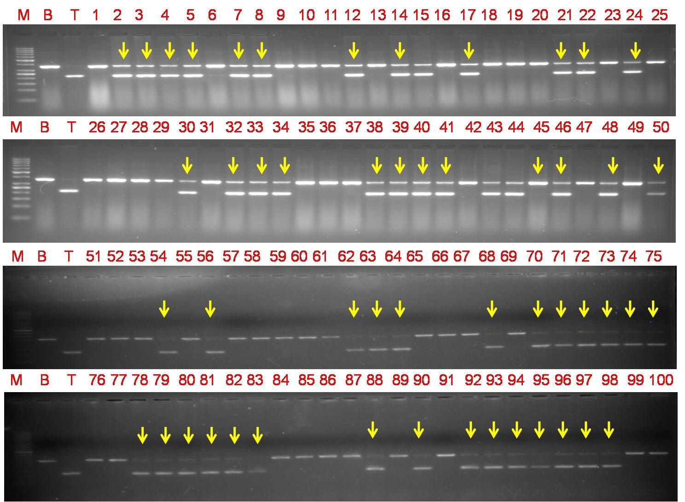Figure 1: The gene linked marker Pi-54 MAS was used for screening of Pi-54 gene in the F₁ plants. The numbers represents the F₁ plants from the cross BPT 5204/Tetep. Gel Lanes M: 50bp molecular weight ladder; B-Recurrent parent ‘BPT 5204 (Samba Mahsuri)’, T- Donor parent ‘Tetep’; 1- 25 - F₁ plants, (line No’s 2, 3, 4, 5, 7, 8, 12, 14, 17, 21, 22, 24, 30, 32, 33, 34, 38, 39, 40, 41, 45, 46, 48, 50, 54, 56, 62, 63, 64, 68, 71, 71, 72, 73, 74, 75, 78, 79, 80, 81, 82, 83, 88, 90, 92, 93, 94, 95, 96, 97 and 98 ‘ heterozygous +ve plants’ for Pi-54 gene).

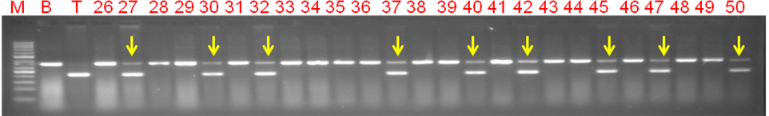Figure 2: The gene linked marker Pi-54 MAS was used for screening of Pi-54 in the BC₁F₁ plants. The numbers represents the BC₁F₁ plants from the cross BPT 5204/Tetep. Gel Lanes M: 50bp molecular weight ladder; B-Recurrent parent ‘BPT 5204 (Samba Mahsuri)’, T-Donor parent ‘Tetep’; 1- 25 - BC₁F₁ plants, (line No’s 27, 30, 32, 37, 40, 42, 45, 47 and 50 ‘heterozygous +ve plants’ for Pi-54 gene).

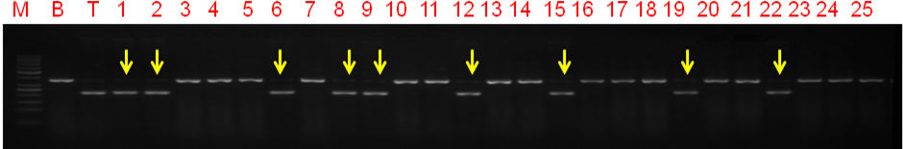Figure 3: The gene linked marker Pi-54 MAS was used for screening of Pi-54 in the BC₂F₂ plants. The numbers represents the BC₂F₂ plants from the cross BPT 5204/Tetep. Gel Lanes M: 50bp molecular weight ladder; B-Recurrent parent ‘BPT 5204 (Samba Mahsuri)’, T-Donor parent ‘Tetep’; 1- 25 - BC₁F₁ plants, (line No’s 1, 2, 6, 8, 9, 12, 15, 19 and 22 ‘homozygous +ve plants’ for Pi-54 gene).

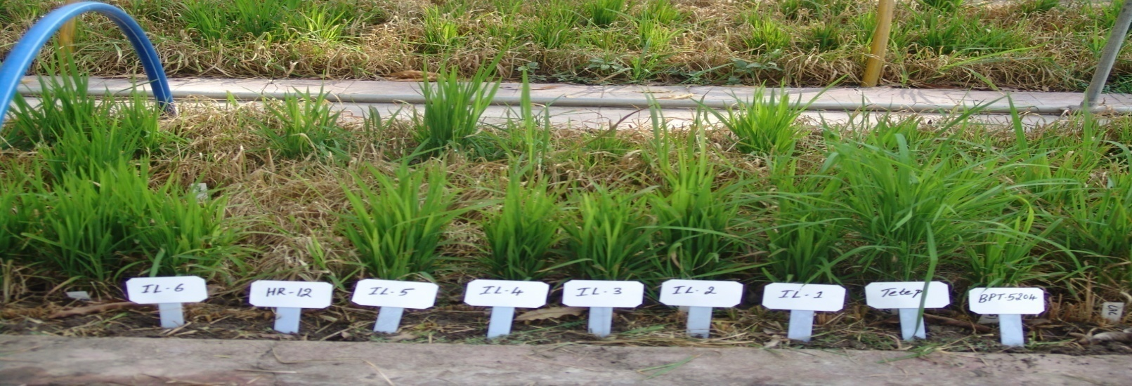Figure 4: Screening of selected BC₂F₂ lines against blast disease following UBN Method, HR-12: Susceptible check, Samba Mahsuri (BPT 5204): Recurrent parent (susceptible) and Tetep: Donor parent ( highly resistant); IL-1 to IL6 (i.e., BT-8-47-22-6, BT-8-47-22-55, BT-8-47-22-117, BT-8-47-22-159, BT-8-47-22-203 and BT-8-47-22-267) introgressed lines.

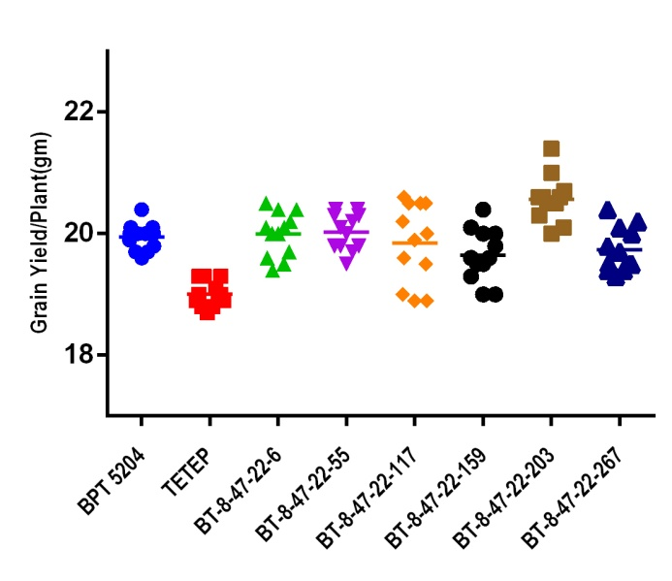
Figure 5: Scatter plot showing IL BT-8-47-22-6-203 found to be better than recurrent parent Samba Mahsuri (BPT 5204) in grain yield per plant and remaining IL’s are mostly similar with the recurrent parent, indicating that the performance of introgression lines were on par with recurrent parent with marginal differences.

Table 1: Details of backcross derived plants from the cross Samba Mahsuri (BPT 5204)/Tetep for foreground and background selection.
S. No | Cross combination | Generation | No. of plants analyzed | Foreground Selection | Background genome selection
 |  |  |  | +ve for Pi54 gene | SSRs analyzed | Polymorphic SSRs, homozygous for R’ allele | Recurrent parent genome Recovery (%) | Selected plant based on background selection
1 | B X T | F₁ | 103 | 57 | - | - | - | BT-8
2 | B X BT-8 | BC₁F₁ | 347 | 86 | 56 | 41 | 73.20% | BT-8-47
3 | B X BT-8-47 | BC₂F₁ | 240 | 59 | 15 | 6 | 83.90% | BT-8-47-22
4 | B X BT 8-47-22 | BC₂F₂ | 419 | 105 | 9 | 5 | 92.80% | BT-8-47-22-6
Note: B=BPT 5204, T=Tetep, BT= NILs of BPT 5204 X Tetep

Table 2: Reaction of the six selected pyramided BC2F4 lines after inoculation with blast isolate (IIRR MSP-28)
S. No. | Designation | Resistance gene Pi-54 genotyped by linked marker Pi-54 MAS | Reaction against to blast disease with IIRR MSP-28 isolate |  | Grain type
S. No. | Designation | Resistance gene Pi-54 genotyped by linked marker Pi-54 MAS | Score* | R/S | Grain type
1 | BPT 5204 | -- | 8.0±1.0 | S | MS
2 | TETEP | ++ | 0.3±0.6 | R | SB
3 | HR-12 | -- | 8.7±0.6 | S | LB
4 | BT-8-47-22-6-36 | ++ | 0.7±0.6 | R | MS
5 | BT-8-47-22-6-55 | ++ | 1.0±1.0 | R | MS
6 | BT-8-47-22-6-117 | ++ | 0.3±0.6 | R | MS
7 | BT-8-47-22-6-159 | ++ | 1.3±0.6 | R | MS
8 | BT-8-47-22-6-203 | ++ | 1.3±0.6 | R | MS
9 | BT-8-47-22-6-267 | ++ | 0.7±0.6 | R | MS
‘++’:- Possessing homozygous resistant allele at the particular gene locus, based on screening with gene linked marker.
‘--’:- Possessing homozygous susceptible allele at the particular gene locus, based on screening with gene linked marker; ‘R’- Resistant; ‘S’- Susceptible; ‘MS’ - Medium Slender and ‘SB; Short Bold respectively.
‘*’:- Mean of the three replications and each replication data was collected from 50 plants.

Table 3: Details of agronomic performance of the parents and introgressed lines of Samba Mahsuri (BPT 5204) at BC2F4 under field conditions
S. No. | Designation | DFF* | DM* | PH* (cm) | PN* | PL* (cm) | GP* | TGW | Y/P** | RPG  (%)
1 | BPT 5204 | 124.0±1.0 | 148.3±1.2 | 78.7±1.5 | 11.0±1.0 | 23.5±0.5 | 179±1.0 | 17.9±0.1 | 19.9±0.2 | -
2 | TETEP | 93.7±1.5 | 128.0±1.0 | 94.3±0.6 | 9.7±0.6 | 22.8±0.8 | 160.3±0.6 | 16.8±0.2 | 19.2±0.2 | -
3 | BT-8-47-22-6-36 | 119.7±0.6 | 144.7±0.6 | 77.3±0.6 | 10.0±1.0 | 23.3±0.3 | 178.7±0.6 | 17.6±0.5 | 20.0±0.4 | 91.1
4 | BT-8-47-22-6-55 | 119.0±1.7 | 142.0±1.0 | 77.7±1.2 | 10.0±1.0 | 23.3±0.6 | 178.0±1.0 | 17.0±0.2 | 20.0±0.3 | 92.6
5 | BT-8-47-22-6-117 | 118.7±0.6 | 141.7±1.2 | 78.3±1.2 | 10.7±0.6 | 23.5±0.5 | 177.3±0.6 | 17.2±0.8 | 19.8±0.7 | 91.9
6 | BT-8-47-22-6-159 | 119.0±2.0 | 141.7±0.6 | 79.7±0.6 | 10.3±0.6 | 23.2±0.3 | 177.0±1.0 | 17.5±0.5 | 19.7±0.4 | 92.5
7 | BT-8-47-22-6-203 | 118.3±2.3 | 141.7±1.2 | 78.3±1.2 | 11.7±0.6 | 23.7±0.3 | 179.3±0.6 | 18.0±0.1 | 20.6±0.4 | 92.8
8 | BT-8-47-22-6-267 | 118.3±1.5 | 142.7±1.7 | 77.7±0.6 | 10.0±1.0 | 23.5±0.5 | 177.07±1.5 | 17.3±0.6 | 19.7±0.4 | 92.0
DFF: Days to 50% flowering, DM: Days to maturity, PH: Mean plant height (cm), PN: No. of panicle per plant, PL: Panicle length (cm), GP: Grain weight (gm), TGW (gm): 1000 grain weight and RPG: Recurrent parent genome recovery (%).
‘*’:- Mean of the three replications; ‘**’:- Mean of the twelve replications.

